

**Patan College for Professional Studies**

Group Report

Extra-Curricular Event Management System

**Event0: We create the best memories**

|

|

|

Submitted By Submitted To

Niraj Chudali(1915677) University of Bedfordshire

Roshan Bist(1915684)

**Table of Contents**

1.Introduction ……………………………………………………………………………...2

2.Objective of the project………………………………………………………………..3

3.Proposed system…………………………………………………………………………3

4.Terms and condtions……………………………………………………………………3

5.Project Plan and Schedule…………………………………………………………….4

6.Requirements analysis…………………………………………………………………5

7.System Design……………………………………………………………………………6

7.1. Diagrams……………………………………………………………………..6

7.2. Database Design……………………………………………………………7

7.2.1. Entity Relationship Model……………………………………..7

7.2.1.1. ERM Diagrams…………………………………………….7

7.7.1.2. Skeleton Tables…………………………………………...7

7.2.2 Data Dictionary……………………………………………………8

7.3 System Exploration…………………………………………………………..9

8.Testing……………………………………………………………………………………..20

9.Software used for development……………………………………………………..21

10.Group Organization and role division…………………………………………….21

11.Conclusion……………………………………………………………………………….22

**1. Introduction**

Extra Curricular-event Management System is the software which allows students to get updates about the events organize by the school. We have developed the software and named it ‘Event0’. The students have to first register to get access the system features. Student name and college identity is the most to register. After registration users can access to the system from anywhere in anytime. Registered users can post an events, book an events, cancel booking and many more. What we do is we create the best memories.

**2.Objective of the Project**

The main goal of the project is to help students get regular updates about their schools. Event0 is the easiest and most convenient way to get daily updates. Students even get updated if they unable to attend regular classes due to some internal problems.

**3.Proposed System**

Event0 is an information system developed using Java where students can easily get information about the events and daily school updates.

**4.Terms and Conditions**

Like every system we have also terms and conditions users have to follow.

1. New students first need to register to access the home page of the system. One student can not register for multiple times using same student id. Student name can be repeatable.
2. While uploading an event organizer must include event name, date, time and venue of the event.
3. Student can book the events.
4. All events are offline events. Online events are not organized due to the some issues with system.
5. Booked events can be canceled anytime they need.
6. School have full control to the events. They can Post or delete the events.
7. Students can excess every features of the system free of cost.

**5.Project plan and schedule**

This is the whole timetable of our project. Despite of the affects of covid-19 we have completed our work in time. We have developed the whole system at the end of february and waited for the submission time.

|  |  |  |
| --- | --- | --- |
| Week No. | Tasks | Priority |
| 10 | System design, Use casees | Design of whole architecture of the system. |
| 11 | User registration and login | Coding implementation in registration and login page |
| 12 | Home page, profile, explore ,my bookings, events. | Designed the different panel for the system. |
| 13 | Database connection | Exploration on mysql and successfully connected the database. |
| 14 | Testing whole system | Used different variable option to check whether our system performs well enough or not. |
| 15 | Research | Research more about projects and added some extra features that best suits the system. |

**6.Requirement Analysis**

6.1 Functional Requirements

* Hosting Events
* Events Booking
* Manage Events
* Maintaining Users
* Updating Events
* Cancelling Events
* Exploring Events

6.2 Operational Requirements/Non-Functional Requirements

* User friendly user interface
* Response time of the system
* Security
* Safety
* Capacity of the system

6.3 Usuability Requirements

* Standardization
* Integration
* Consistency
* Protability

**7.System Design**

7.1. Class Diagram

This is the main architecture of the system. When the user first started our system the login page is initialize. Registered users can easily registered using Fullname and Identity where as new users have to first registered into the system to access our main dashboard.

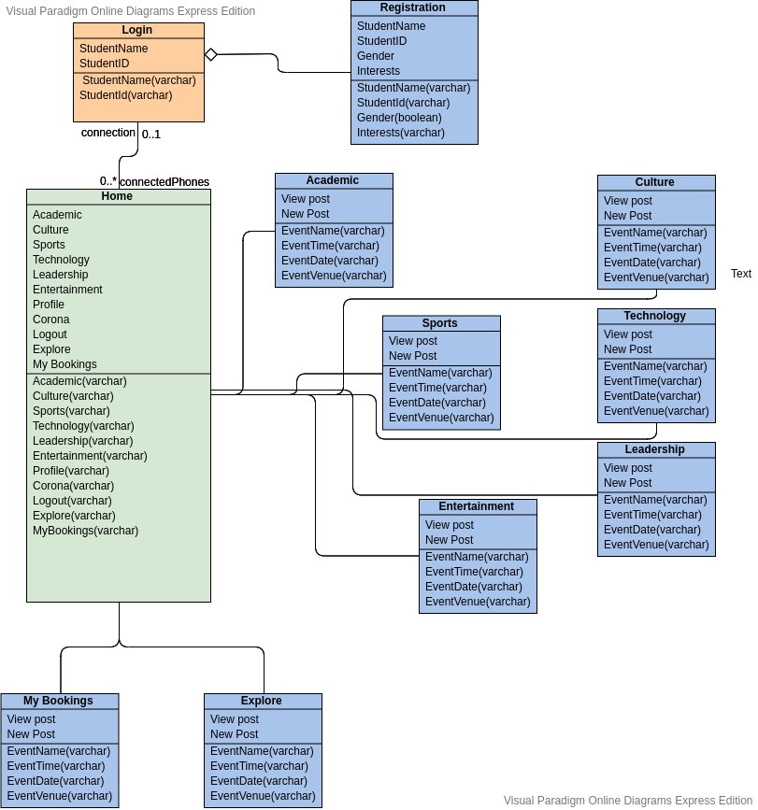

7.2. Database Design

7.2.1. Entity Relationship Model

Entity relationship model is the database model which is used to define data elements and their relationships.

7.2.1.1. Entity Relationship Diagrams

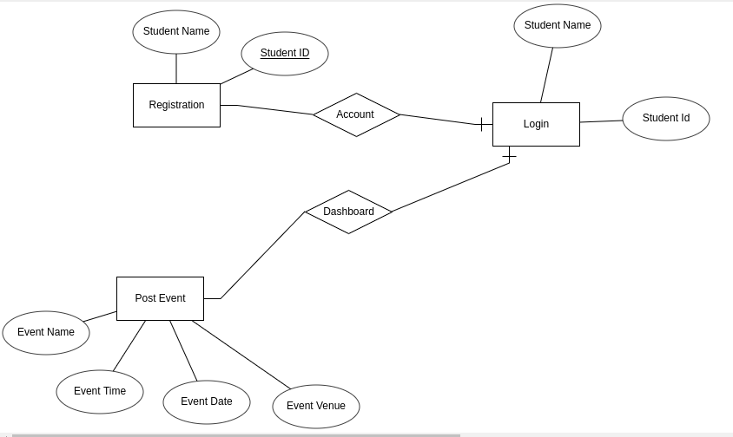

7.2.1.2. Skeleton Table

This is our database design using phpmyadmin. We have used xampp. The database consists of eight tables named Academic,culture,entertainment,leadership,sports,technology,mybookings and studentInfo.

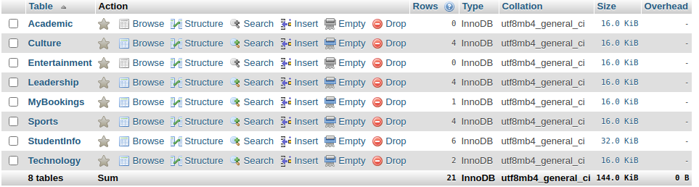

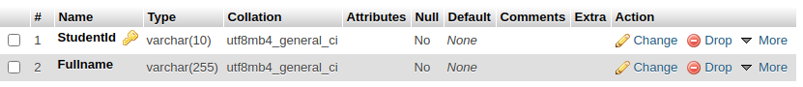

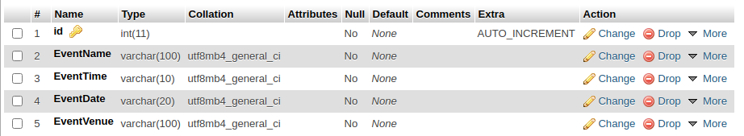

7.2.2 Data Dictionary

|  |  |  |  |  |
| --- | --- | --- | --- | --- |
| Entity | Attributes | Types | Description | Required |
| User | Student_id | Primary key, varchar | Must be unique and more than or equals to 5 characters long. | Y |
| Student_name | varchar | More than or equals to 5 character long. Can be repeatable. | Y |
| Events | event_name | varchar | Must not be null supports multiple characters. | Y |
| event_time | varchar | Must not be null supports multiple characters. | Y |
| event_date | varchar | Must not be null supports multiple characters. | Y |
| event_venue | varchar | Must not be null supports multiple characters. | Y |

7.3.System Exploration

Let’s Explore our system step by step.

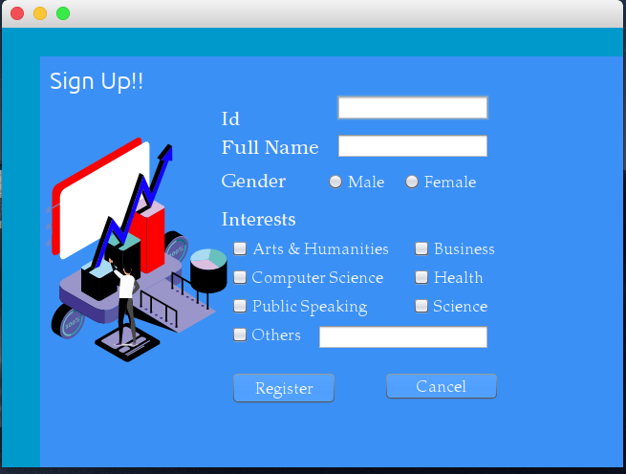

This is the registration Page of the system. New user must register in to the system. Student Id and full name are mandatory where as gender and Interest are optional.

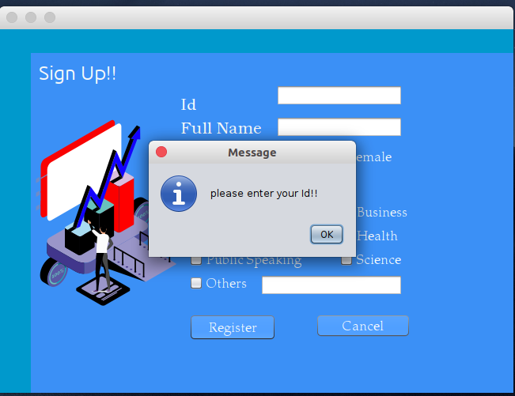

If the user tries to create the account without using name or id the system displays the error message.

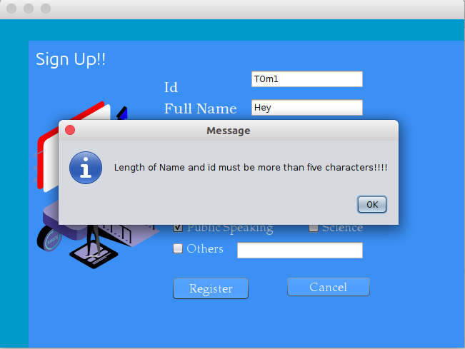

The student id and student name should be less than or equals to five characters long.

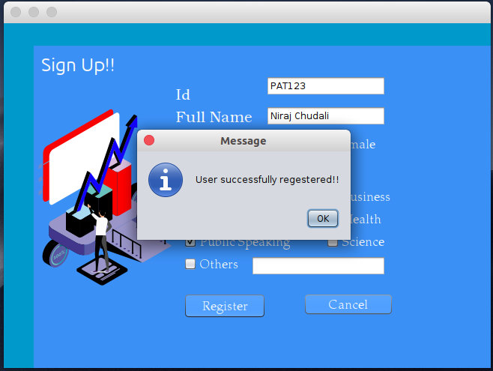

If the username and id matches the requirement of the system the new user will be successfully registered.

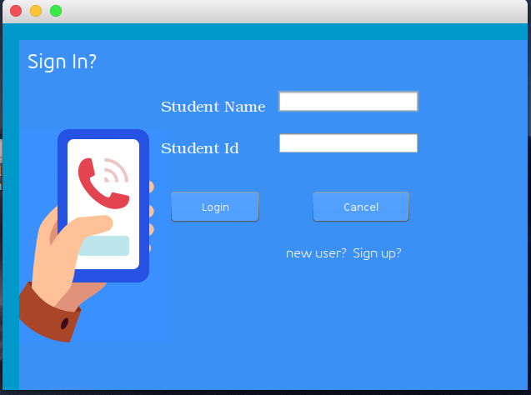

This is the Login page of the system. Registered users can directly login to the system using their Name and id.

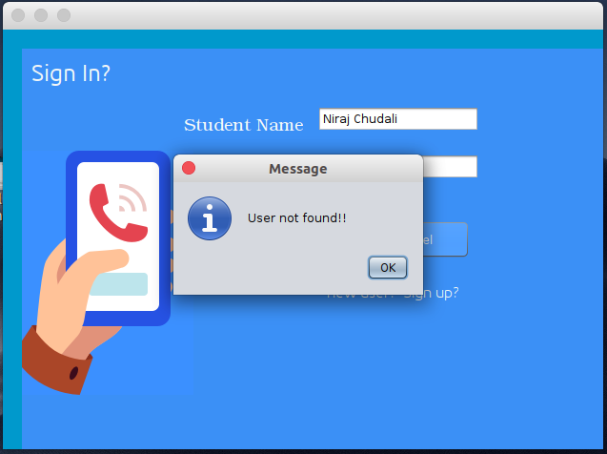

If the user name is does not match the user not found message pop out in the screen . So the new user must first login into the system.

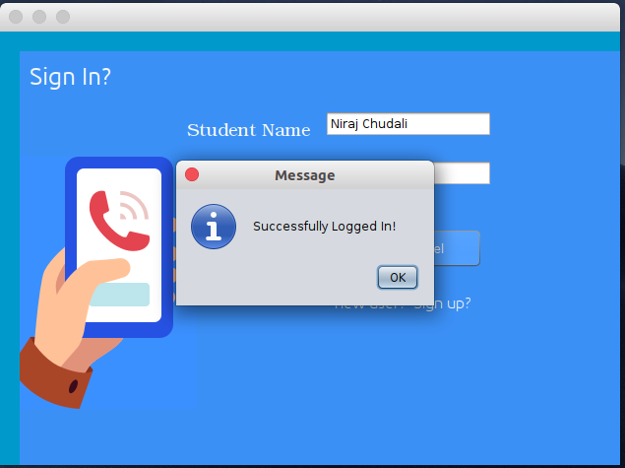

If the Student name and student id matches the student can successfully logged into the system.

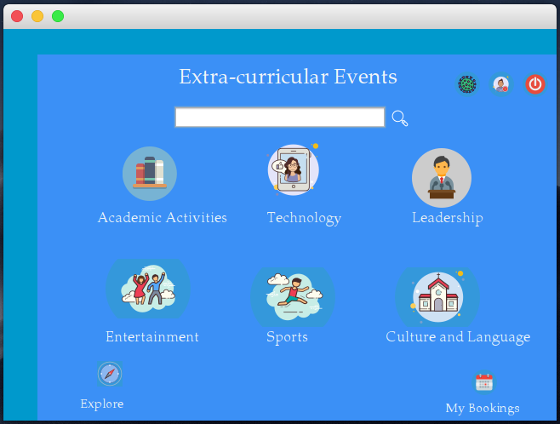

This is the home page of our system. The main dashboard consists of different events like academic, technology, Leadership, Entertainment, Sports , Culture and Language. Students can search the different events. In the top right corner we have red icon which is the logout button. The middle one is the student profile and the first one is the new features which gives the information about the current pandemic corona virus. In the bottom left there is an explore button. Using this students can easily explore the different events posted in the system. And in the bottom right there is a my booking tab where students can see their bookings.

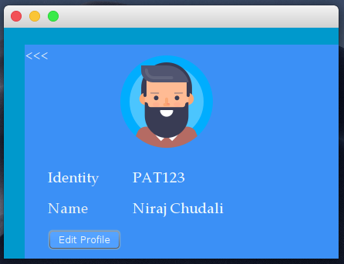

This is the profile of the currently logged in user.

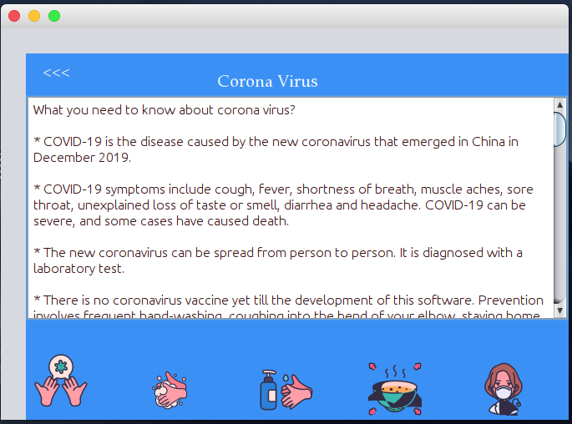

This is the new feature of the system which gives information about corona virus, its causes, symptoms and preventive measures.

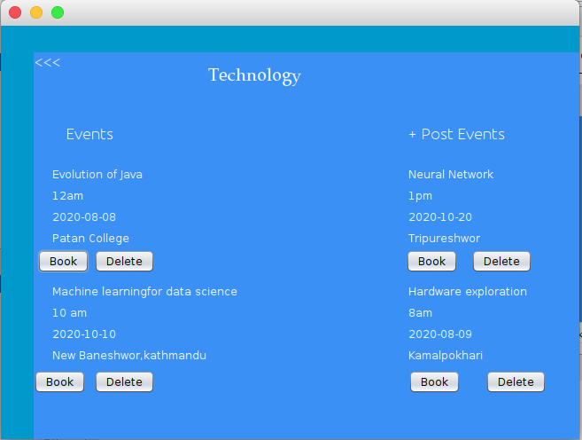

This is the technology event home page. From here users can Book an event and event poster can delete an event. The new events can be created by clicking the post event. The same process applies for other events also.

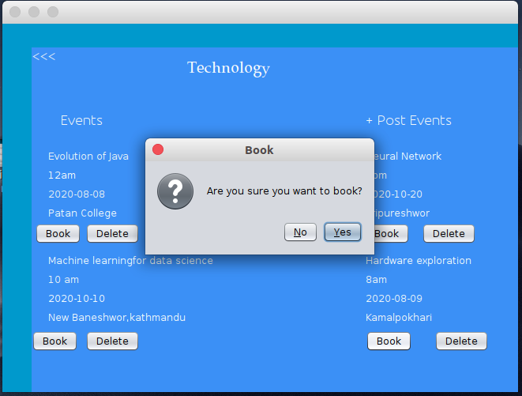

When the user clicks the book button the message popup in the screen saying ‘Are you sure you want to book?’ if the user click on yes the event will be booked and when pressed no nothing will happens.

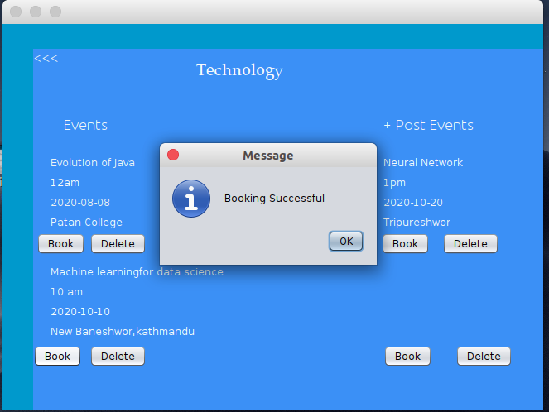

After successfully booked event the user can see his events from my bookings.

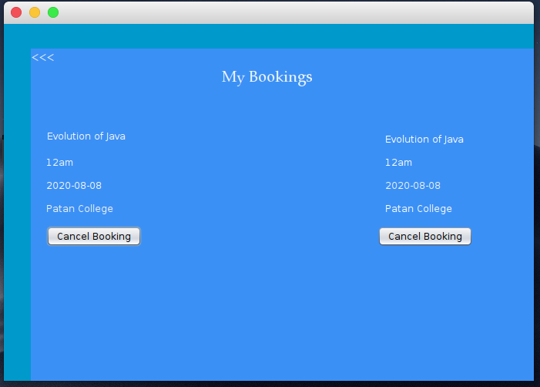

This is the my bookings page. I have already registered two events. I can cancel my events whenever I need.

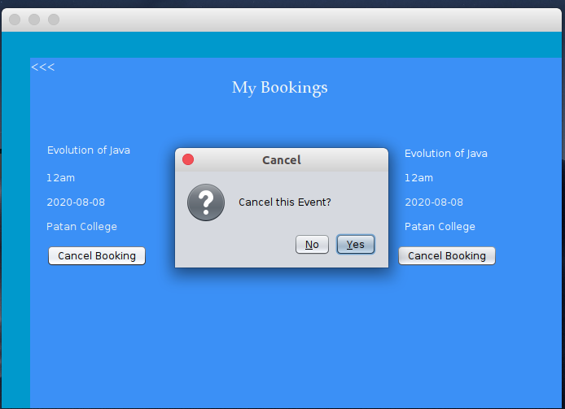

When I pressed cancel booking the message saying ‘Cancel this event?’ pops us when I pressed yes the events will be deleted from my bookings.

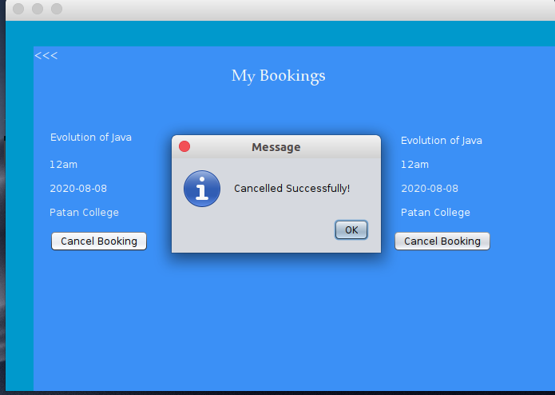

Here it is. I have successfully canceled my event.

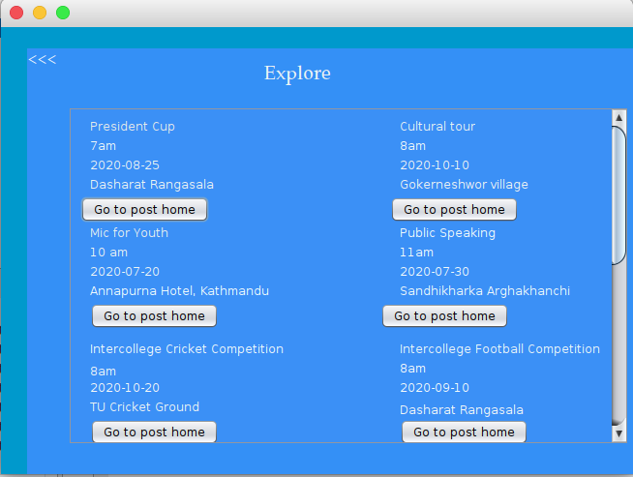

There is an explore icon in the home page of the user interface. When the user click that icon, this page will be loaded. In the page user can see every posted image and directly go to the event home page. User can’t directly register through this site. The motivation for this page is from instagram explore tab.

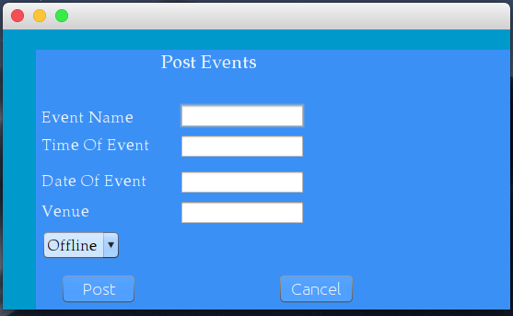

User can post an event by clicking in the ‘+post event’ label from the event home page. To post the event user have to give the name, time, date and venue of the events. Till the data all events are offline events.

The system will notify when we updated to online.

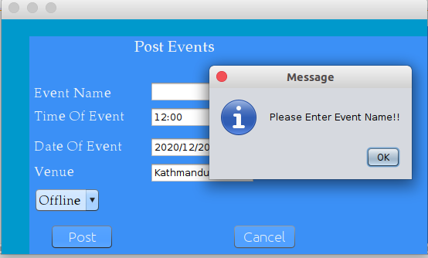

If any of the sides are missing the error message will pop out. So the all field should be appropriate as required by the system.

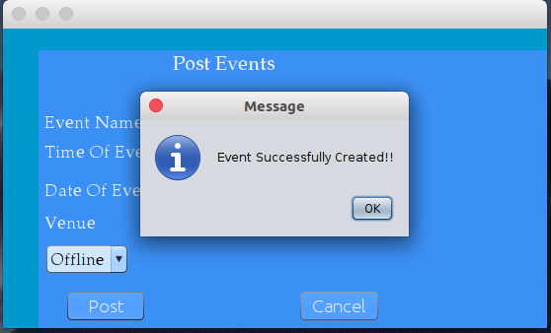

If everything is ok and user fulfill the system requirement the event will successfully registered.

Let’s get back to our home page.



Finally, log out from our system by clicking on the red icon on top right side corner.

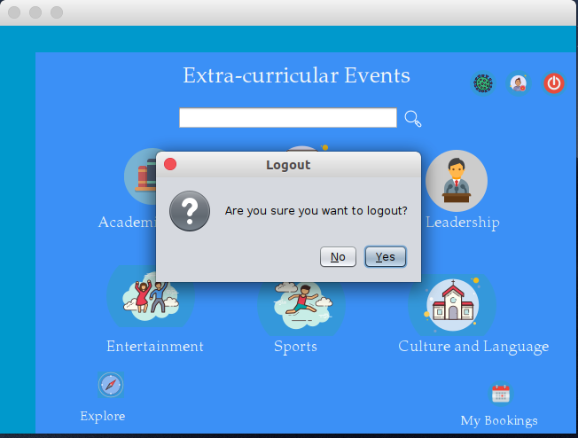

**9. Testing**

The below mentioned screenshots are table in our database. For the testing purpose we use these tables.

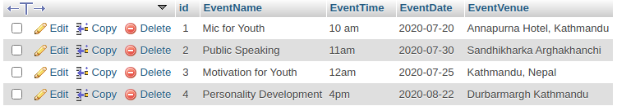

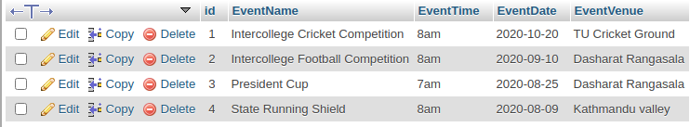

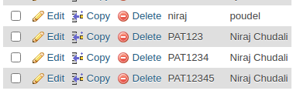

|  |  |  |  |
| --- | --- | --- | --- |
| Reason for Testing | Input | Result | Expected Result |
| The student must be more than or equals to 5 characters long. | Student name | Message pop up displaying name must be 5 characters long |  |
| The Student id must be unique and must be more than or equals to 5 characters long. | Student Id | Message pop up displaying id must be unique or id must be more than or equals to 5 characters long. |  |
| No fields must be empty while posting an event. | Event name,time,data and venue | Window displays the information saying fields mustnot be empty if any of the fields are empty. |  |

**10. Software used for Development**

For the development of the whole software we use Gimp and Photoshop for editing images, Netbeans as a jave ide, Mysql database to store the data.

**11. Group Organization and role division**

Before starting the project we divide our work equally to two of us

|  |  |  |
| --- | --- | --- |
| Student Id | Student Name | Roles |
| 1915677 | Niraj Chudali | Developer, Analyst |
| 1915684 | Roshan Bist | Designer, Tester |

Group Division

|  |  |  |
| --- | --- | --- |
| S.n | Name | Work Division |
| 1. | Niraj Chudali | Login, Registration, Homepage, Explore, My Events,Database Connection, My Bookings,Logout. |
| 2. | Roshan Bist | Event home page, View Event,Post Event, Cancel Event,Book Event, Testing of system, Brainstorming. |

**12. Conclusion**

From this project we get the opportunity to learn lots of new things. With the team effort we successfully built this fully functioning system. This project helps to motivate us and we will be able to built these types of software using the same knowledge we have used in this project. We are thankful to everyone who helped during the whole software development process. And we hope that we have successfully purposed the system that is assigned by the university of Bedfordshire.

**Code**

package javaapplication;

import java.awt.Color;

import java.awt.Container;

import java.sql.DriverManager;

import java.sql.PreparedStatement;

import java.sql.SQLException;

import java.util.logging.Level;

import java.util.logging.Logger;

import javax.swing.JOptionPane;

import java.sql.ResultSet;

public class Login extends javax.swing.JFrame {

public Login() {

Container c = getContentPane();

c.setBackground(new Color(0,153,204));

initComponents();

}

java.sql.Connection con;

PreparedStatement pst;

ResultSet rs;

public boolean validation(){

String StudentName,StudentId;

StudentName = txtname.getText();

StudentId = txtid.getText();

if (StudentName.equals(""))

{

JOptionPane.showMessageDialog(this, "please enter your Name!!");

return false;

}

else if (StudentId.equals(""))

{

JOptionPane.showMessageDialog(this, "please enter your id!!");

return false;

}

else

{

try {

Class.forName("com.mysql.cj.jdbc.Driver");

con = DriverManager.getConnection("jdbc:mysql://localhost/javaProject","root","");

pst = con.prepareStatement("select * from StudentInfo where StudentId=? and Fullname=?");

pst.setString(1, StudentId);

pst.setString(2, StudentName);

rs = pst.executeQuery();

if(rs.next()){

JOptionPane.showMessageDialog(this, "Successfully Logged In!");

HomePage home = new HomePage();

this.hide();

home.setVisible(true);

}

else{

JOptionPane.showMessageDialog(this, "User not found!!");

}

} catch (ClassNotFoundException ex) {

Logger.getLogger(Login.class.getName()).log(Level.SEVERE, null, ex);

} catch (SQLException ex) {

Logger.getLogger(Login.class.getName()).log(Level.SEVERE, null, ex);

}

}

return true;

}

private void initComponents() {

jPanel2 = new javax.swing.JPanel();

jLabel1 = new javax.swing.JLabel();

jLabel2 = new javax.swing.JLabel();

jLabel3 = new javax.swing.JLabel();

txtname = new javax.swing.JTextField();

jLabel4 = new javax.swing.JLabel();

txtid = new javax.swing.JTextField();

jButton1 = new javax.swing.JButton();

jButton2 = new javax.swing.JButton();

jLabel5 = new javax.swing.JLabel();

setDefaultCloseOperation(javax.swing.WindowConstants.EXIT_ON_CLOSE);

getContentPane().setLayout(new org.netbeans.lib.awtextra.AbsoluteLayout());

jPanel2.setBackground(new java.awt.Color(59, 144, 246));

jPanel2.setLayout(new org.netbeans.lib.awtextra.AbsoluteLayout());

jLabel1.setFont(new java.awt.Font("Ubuntu", 0, 25)); // NOI18N

jLabel1.setForeground(new java.awt.Color(242, 246, 247));

jLabel1.setText("Sign In?");

jPanel2.add(jLabel1, new org.netbeans.lib.awtextra.AbsoluteConstraints(10, 10, 110, 30));

jLabel2.setFont(new java.awt.Font("URW Bookman L", 0, 18)); // NOI18N

jLabel2.setForeground(new java.awt.Color(247, 248, 248));

jLabel2.setText("Student Name");

jPanel2.add(jLabel2, new org.netbeans.lib.awtextra.AbsoluteConstraints(170, 60, 130, 40));

jLabel3.setFont(new java.awt.Font("URW Bookman L", 0, 18)); // NOI18N

jLabel3.setForeground(new java.awt.Color(247, 248, 248));

jLabel3.setText("Student Id");

jPanel2.add(jLabel3, new org.netbeans.lib.awtextra.AbsoluteConstraints(170, 110, 110, 40));

jPanel2.add(txtname, new org.netbeans.lib.awtextra.AbsoluteConstraints(310, 60, 170, -1));

jLabel4.setFont(new java.awt.Font("Ubuntu", 0, 16)); // NOI18N

jLabel4.setForeground(new java.awt.Color(248, 249, 245));

jLabel4.setText("new user? Sign up?");

jLabel4.addMouseListener(new java.awt.event.MouseAdapter() {

public void mouseClicked(java.awt.event.MouseEvent evt) {

jLabel4MouseClicked(evt);

}

});

jPanel2.add(jLabel4, new org.netbeans.lib.awtextra.AbsoluteConstraints(320, 240, 170, 30));

jPanel2.add(txtid, new org.netbeans.lib.awtextra.AbsoluteConstraints(310, 110, 170, -1));

jButton1.setBackground(new java.awt.Color(59, 144, 246));

jButton1.setForeground(new java.awt.Color(244, 247, 248));

jButton1.setText("Login");

jButton1.addMouseListener(new java.awt.event.MouseAdapter() {

public void mouseClicked(java.awt.event.MouseEvent evt) {

jButton1MouseClicked(evt);

}

});

jPanel2.add(jButton1, new org.netbeans.lib.awtextra.AbsoluteConstraints(180, 180, 110, 40));

jButton2.setBackground(new java.awt.Color(59, 144, 246));

jButton2.setForeground(new java.awt.Color(249, 251, 252));

jButton2.setText("Cancel");

jButton2.addActionListener(new java.awt.event.ActionListener() {

public void actionPerformed(java.awt.event.ActionEvent evt) {

jButton2ActionPerformed(evt);

}

});

jPanel2.add(jButton2, new org.netbeans.lib.awtextra.AbsoluteConstraints(350, 180, 120, 40));

jLabel5.setIcon(new javax.swing.ImageIcon(getClass().getResource("/javaapplication/icons/5964548-256.png"))); // NOI18N

jLabel5.setText("jLabel5");

jPanel2.add(jLabel5, new org.netbeans.lib.awtextra.AbsoluteConstraints(-50, 70, 230, 330));

getContentPane().add(jPanel2, new org.netbeans.lib.awtextra.AbsoluteConstraints(20, 20, 610, 420));

pack();

setLocationRelativeTo(null);

}// </editor-fold>

private void jButton1MouseClicked(java.awt.event.MouseEvent evt) {

validation();

}

private void jLabel4MouseClicked(java.awt.event.MouseEvent evt) {

Registration rp = new Registration();

this.hide();

rp.setVisible(true);

}

private void jButton2ActionPerformed(java.awt.event.ActionEvent evt) {

System.exit(0);

}

public static void main(String args[]) {

java.awt.EventQueue.invokeLater(new Runnable() {

public void run() {

new Login().setVisible(true);

}

});

}

package javaapplication;

import java.awt.Color;

import java.awt.Container;

import javax.swing.JOptionPane;

import java.sql.*;

import java.util.logging.Level;

import java.util.logging.Logger;

import java.sql.PreparedStatement;

public class Registration extends javax.swing.JFrame {

public Registration() {

Container c = getContentPane();

c.setBackground(new Color(0,153,204));

initComponents();

}

Connection con;

PreparedStatement pst;

public boolean validation(){

String id,fullname,gender,interests,others;

id = txtid.getText();

fullname = txtname.getText();

others = txtothers.getText();

if(id.equals("")){

JOptionPane.showMessageDialog(this, "please enter your Id!!");

return false;

}

else if(fullname.equals("")){

JOptionPane.showMessageDialog(this, "please enter your Name!!");

return false;

}

else if(fullname.length()<=5){

JOptionPane.showMessageDialog(this, "Length of Name and id must be more than five characters!!!!");

return false;

}

else if(id.length()<=5)

{

JOptionPane.showMessageDialog(this, "Length of Name and Id must be more than five character!");

return false;

}

else{

try {

id = txtid.getText();

fullname = txtname.getText();

Class.forName("com.mysql.cj.jdbc.Driver");

con = DriverManager.getConnection("jdbc:mysql://localhost/javaProject","root","");

pst = con.prepareStatement("insert into StudentInfo(StudentId,FUllname)values(?,?)");

pst.setString(1, id);

pst.setString(2, fullname);

pst.executeUpdate();

JOptionPane.showMessageDialog(null, "User successfully regestered!!");

txtid.setText("");

txtname.setText("");

Login ln = new Login();

this.hide();

ln.setVisible(true);

} catch (ClassNotFoundException ex) {

Logger.getLogger(Registration.class.getName()).log(Level.SEVERE, null, ex);

} catch (SQLException ex) {

Logger.getLogger(Registration.class.getName()).log(Level.SEVERE, null, ex);

}

}

return true;

}

private void initComponents() {

jPanel1 = new javax.swing.JPanel();

jLabel1 = new javax.swing.JLabel();

jLabel2 = new javax.swing.JLabel();

jLabel3 = new javax.swing.JLabel();

txtname = new javax.swing.JTextField();

txtid = new javax.swing.JTextField();

jLabel4 = new javax.swing.JLabel();

jLabel5 = new javax.swing.JLabel();

jCheckBox1 = new javax.swing.JCheckBox();

jCheckBox2 = new javax.swing.JCheckBox();

jCheckBox4 = new javax.swing.JCheckBox();

jCheckBox5 = new javax.swing.JCheckBox();

jCheckBox3 = new javax.swing.JCheckBox();

jCheckBox6 = new javax.swing.JCheckBox();

jButton1 = new javax.swing.JButton();

jButton2 = new javax.swing.JButton();

jCheckBox7 = new javax.swing.JCheckBox();

txtothers = new javax.swing.JTextField();

male = new javax.swing.JRadioButton();

female = new javax.swing.JRadioButton();

jLabel6 = new javax.swing.JLabel();

setDefaultCloseOperation(javax.swing.WindowConstants.EXIT_ON_CLOSE);

getContentPane().setLayout(new org.netbeans.lib.awtextra.AbsoluteLayout());

jPanel1.setBackground(new java.awt.Color(59, 144, 246));

jPanel1.setForeground(new java.awt.Color(244, 247, 248));

jPanel1.setLayout(new org.netbeans.lib.awtextra.AbsoluteLayout());

jLabel1.setFont(new java.awt.Font("Ubuntu", 0, 25)); // NOI18N

jLabel1.setForeground(new java.awt.Color(247, 248, 248));

jLabel1.setText("Sign Up!!");

jPanel1.add(jLabel1, new org.netbeans.lib.awtextra.AbsoluteConstraints(10, 10, 110, 30));

jLabel2.setFont(new java.awt.Font("URW Bookman L", 0, 20)); // NOI18N

jLabel2.setForeground(new java.awt.Color(247, 248, 248));

jLabel2.setText("Full Name");

jPanel1.add(jLabel2, new org.netbeans.lib.awtextra.AbsoluteConstraints(190, 80, 110, 30));

jLabel3.setFont(new java.awt.Font("URW Palladio L", 0, 20)); // NOI18N

jLabel3.setForeground(new java.awt.Color(246, 250, 252));

jLabel3.setText("Id");

jPanel1.add(jLabel3, new org.netbeans.lib.awtextra.AbsoluteConstraints(190, 50, 70, 30));

jPanel1.add(txtname, new org.netbeans.lib.awtextra.AbsoluteConstraints(310, 80, 160, -1));

jPanel1.add(txtid, new org.netbeans.lib.awtextra.AbsoluteConstraints(310, 40, 160, -1));

jLabel4.setFont(new java.awt.Font("URW Palladio L", 0, 20)); // NOI18N

jLabel4.setForeground(new java.awt.Color(243, 244, 245));

jLabel4.setText("Gender");

jPanel1.add(jLabel4, new org.netbeans.lib.awtextra.AbsoluteConstraints(190, 110, 100, 40));

jLabel5.setFont(new java.awt.Font("URW Palladio L", 0, 20)); // NOI18N

jLabel5.setForeground(new java.awt.Color(244, 247, 248));

jLabel5.setText("Interests");

jPanel1.add(jLabel5, new org.netbeans.lib.awtextra.AbsoluteConstraints(190, 150, 80, 40));

jCheckBox1.setFont(new java.awt.Font("URW Palladio L", 0, 17)); // NOI18N

jCheckBox1.setForeground(new java.awt.Color(241, 247, 248));

jCheckBox1.setText("Arts & Humanities");

jCheckBox1.addActionListener(new java.awt.event.ActionListener() {

public void actionPerformed(java.awt.event.ActionEvent evt) {

jCheckBox1ActionPerformed(evt);

}

});

jPanel1.add(jCheckBox1, new org.netbeans.lib.awtextra.AbsoluteConstraints(200, 190, -1, -1));

jCheckBox2.setFont(new java.awt.Font("URW Palladio L", 0, 17)); // NOI18N

jCheckBox2.setForeground(new java.awt.Color(241, 247, 248));

jCheckBox2.setText("Business");

jPanel1.add(jCheckBox2, new org.netbeans.lib.awtextra.AbsoluteConstraints(390, 190, -1, -1));

jCheckBox4.setFont(new java.awt.Font("URW Palladio L", 0, 17)); // NOI18N

jCheckBox4.setForeground(new java.awt.Color(247, 248, 248));

jCheckBox4.setText("Computer Science");

jCheckBox4.addActionListener(new java.awt.event.ActionListener() {

public void actionPerformed(java.awt.event.ActionEvent evt) {

jCheckBox4ActionPerformed(evt);

}

});

jPanel1.add(jCheckBox4, new org.netbeans.lib.awtextra.AbsoluteConstraints(200, 220, -1, -1));

jCheckBox5.setFont(new java.awt.Font("URW Palladio L", 0, 17)); // NOI18N

jCheckBox5.setForeground(new java.awt.Color(252, 252, 252));

jCheckBox5.setText("Health");

jPanel1.add(jCheckBox5, new org.netbeans.lib.awtextra.AbsoluteConstraints(390, 220, -1, -1));

jCheckBox3.setFont(new java.awt.Font("URW Palladio L", 0, 17)); // NOI18N

jCheckBox3.setForeground(new java.awt.Color(244, 247, 248));

jCheckBox3.setText("Public Speaking");

jPanel1.add(jCheckBox3, new org.netbeans.lib.awtextra.AbsoluteConstraints(200, 250, -1, -1));

jCheckBox6.setFont(new java.awt.Font("URW Palladio L", 0, 17)); // NOI18N

jCheckBox6.setForeground(new java.awt.Color(248, 252, 253));

jCheckBox6.setText("Science");

jPanel1.add(jCheckBox6, new org.netbeans.lib.awtextra.AbsoluteConstraints(390, 250, -1, -1));

jButton1.setBackground(new java.awt.Color(59, 144, 246));

jButton1.setFont(new java.awt.Font("URW Palladio L", 0, 17)); // NOI18N

jButton1.setForeground(new java.awt.Color(244, 249, 250));

jButton1.setText("Register");

jButton1.addMouseListener(new java.awt.event.MouseAdapter() {

public void mouseClicked(java.awt.event.MouseEvent evt) {

jButton1MouseClicked(evt);

}

});

jButton1.addActionListener(new java.awt.event.ActionListener() {

public void actionPerformed(java.awt.event.ActionEvent evt) {

jButton1ActionPerformed(evt);

}

});

jPanel1.add(jButton1, new org.netbeans.lib.awtextra.AbsoluteConstraints(200, 330, 110, -1));

jButton2.setBackground(new java.awt.Color(59, 144, 246));

jButton2.setFont(new java.awt.Font("URW Palladio L", 0, 17)); // NOI18N

jButton2.setForeground(new java.awt.Color(252, 252, 252));

jButton2.setText("Cancel");

jButton2.addMouseListener(new java.awt.event.MouseAdapter() {

public void mouseClicked(java.awt.event.MouseEvent evt) {

jButton2MouseClicked(evt);

}

});

jPanel1.add(jButton2, new org.netbeans.lib.awtextra.AbsoluteConstraints(360, 330, 120, 30));

jCheckBox7.setFont(new java.awt.Font("URW Palladio L", 0, 17)); // NOI18N

jCheckBox7.setForeground(new java.awt.Color(239, 245, 247));

jCheckBox7.setText("Others");

jPanel1.add(jCheckBox7, new org.netbeans.lib.awtextra.AbsoluteConstraints(200, 280, -1, -1));

jPanel1.add(txtothers, new org.netbeans.lib.awtextra.AbsoluteConstraints(290, 280, 180, -1));

male.setFont(new java.awt.Font("URW Palladio L", 0, 17)); // NOI18N

male.setForeground(new java.awt.Color(241, 247, 248));

male.setText("Male");

male.addActionListener(new java.awt.event.ActionListener() {

public void actionPerformed(java.awt.event.ActionEvent evt) {

maleActionPerformed(evt);

}

});

male.addPropertyChangeListener(new java.beans.PropertyChangeListener() {

public void propertyChange(java.beans.PropertyChangeEvent evt) {

malePropertyChange(evt);

}

});

jPanel1.add(male, new org.netbeans.lib.awtextra.AbsoluteConstraints(300, 120, -1, -1));

female.setFont(new java.awt.Font("URW Palladio L", 0, 17)); // NOI18N

female.setForeground(new java.awt.Color(244, 249, 250));

female.setText("Female");

female.setDoubleBuffered(true);

female.setEnabled(false);

female.addActionListener(new java.awt.event.ActionListener() {

public void actionPerformed(java.awt.event.ActionEvent evt) {

femaleActionPerformed(evt);

}

});

jPanel1.add(female, new org.netbeans.lib.awtextra.AbsoluteConstraints(380, 120, -1, -1));

jLabel6.setIcon(new javax.swing.ImageIcon(getClass().getResource("/javaapplication/icons/4341272-256.png"))); // NOI18N

jPanel1.add(jLabel6, new org.netbeans.lib.awtextra.AbsoluteConstraints(-40, 30, -1, 360));

getContentPane().add(jPanel1, new org.netbeans.lib.awtextra.AbsoluteConstraints(40, 30, 610, 430));

pack();

setLocationRelativeTo(null);

}// </editor-fold>

private void jButton1MouseClicked(java.awt.event.MouseEvent evt) {

validation();

}

private void femaleActionPerformed(java.awt.event.ActionEvent evt) {

// TODO add your handling code here:

int Female = 0;

if (female.isSelected()){

Female=1;

}

}

private void maleActionPerformed(java.awt.event.ActionEvent evt) {

int Male=0;

if(male.isSelected()){

Male = 1;

}

}

private void jButton1ActionPerformed(java.awt.event.ActionEvent evt) {

}

private void jButton2MouseClicked(java.awt.event.MouseEvent evt) {

Login lg = new Login();

this.hide();

lg.setVisible(true);

}

public static void main(String args[]) {

java.awt.EventQueue.invokeLater(new Runnable() {

public void run() {

new Registration().setVisible(true);

}

});

}

package javaapplication;

import java.awt.Color;

import java.awt.Container;

import java.sql.Connection;

import java.sql.DriverManager;

import java.sql.PreparedStatement;

import java.sql.ResultSet;

import javax.swing.JFrame;

import javax.swing.JOptionPane;

public class HomePage extends javax.swing.JFrame {

public HomePage() {

Container c = getContentPane();

c.setBackground(new Color(0,153,204));

initComponents();

}

private void initComponents() {

jPanel1 = new javax.swing.JPanel();

jLabel2 = new javax.swing.JLabel();

jLabel1 = new javax.swing.JLabel();

jLabel3 = new javax.swing.JLabel();

jLabel4 = new javax.swing.JLabel();

jLabel5 = new javax.swing.JLabel();

jLabel6 = new javax.swing.JLabel();

jLabel7 = new javax.swing.JLabel();

jTextField1 = new javax.swing.JTextField();

jLabel8 = new javax.swing.JLabel();

jLabel9 = new javax.swing.JLabel();

Logout = new javax.swing.JLabel();

jLabel11 = new javax.swing.JLabel();

jLabel10 = new javax.swing.JLabel();

jLabel12 = new javax.swing.JLabel();

jLabel13 = new javax.swing.JLabel();

jLabel14 = new javax.swing.JLabel();

jLabel15 = new javax.swing.JLabel();

jLabel16 = new javax.swing.JLabel();

jLabel17 = new javax.swing.JLabel();

jLabel18 = new javax.swing.JLabel();

jLabel20 = new javax.swing.JLabel();

jLabel19 = new javax.swing.JLabel();

setDefaultCloseOperation(javax.swing.WindowConstants.EXIT_ON_CLOSE);

getContentPane().setLayout(new org.netbeans.lib.awtextra.AbsoluteLayout());

jPanel1.setBackground(new java.awt.Color(59, 144, 246));

jPanel1.setLayout(new org.netbeans.lib.awtextra.AbsoluteLayout());

jLabel2.setBackground(new java.awt.Color(59, 144, 246));

jLabel2.setFont(new java.awt.Font("URW Palladio L", 0, 25)); // NOI18N

jLabel2.setForeground(new java.awt.Color(245, 246, 247));

jLabel2.setText(" Extra-curricular Events ");

jPanel1.add(jLabel2, new org.netbeans.lib.awtextra.AbsoluteConstraints(160, 0, 270, 50));

jLabel1.setForeground(new java.awt.Color(245, 246, 247));

jLabel1.setIcon(new javax.swing.ImageIcon(getClass().getResource("/javaapplication/icons/iconfinder_bookshelf_1055107.png"))); // NOI18N

jLabel1.addMouseListener(new java.awt.event.MouseAdapter() {

public void mouseClicked(java.awt.event.MouseEvent evt) {

jLabel1MouseClicked(evt);

}

});

jPanel1.add(jLabel1, new org.netbeans.lib.awtextra.AbsoluteConstraints(100, 100, 70, 80));

jLabel3.setForeground(new java.awt.Color(246, 250, 252));

jLabel3.setIcon(new javax.swing.ImageIcon(getClass().getResource("/javaapplication/icons/icons8-ipad-like-100.png"))); // NOI18N

jLabel3.addMouseListener(new java.awt.event.MouseAdapter() {

public void mouseClicked(java.awt.event.MouseEvent evt) {

jLabel3MouseClicked(evt);

}

});

jPanel1.add(jLabel3, new org.netbeans.lib.awtextra.AbsoluteConstraints(250, 100, 110, 70));

jLabel4.setForeground(new java.awt.Color(244, 247, 248));

jLabel4.setIcon(new javax.swing.ImageIcon(getClass().getResource("/javaapplication/icons/icons8-politician-70.png"))); // NOI18N

jLabel4.addMouseListener(new java.awt.event.MouseAdapter() {

public void mouseClicked(java.awt.event.MouseEvent evt) {

jLabel4MouseClicked(evt);

}

});

jPanel1.add(jLabel4, new org.netbeans.lib.awtextra.AbsoluteConstraints(440, 110, 80, 70));

jLabel5.setForeground(new java.awt.Color(245, 246, 247));

jLabel5.setIcon(new javax.swing.ImageIcon(getClass().getResource("/javaapplication/icons/icons8-party-100.png"))); // NOI18N

jLabel5.addMouseListener(new java.awt.event.MouseAdapter() {

public void mouseClicked(java.awt.event.MouseEvent evt) {

jLabel5MouseClicked(evt);

}

});

jPanel1.add(jLabel5, new org.netbeans.lib.awtextra.AbsoluteConstraints(80, 240, 110, 70));

jLabel6.setForeground(new java.awt.Color(249, 251, 252));

jLabel6.setIcon(new javax.swing.ImageIcon(getClass().getResource("/javaapplication/icons/icons8-track-and-field-100.png"))); // NOI18N

jLabel6.addMouseListener(new java.awt.event.MouseAdapter() {

public void mouseClicked(java.awt.event.MouseEvent evt) {

jLabel6MouseClicked(evt);

}

});

jPanel1.add(jLabel6, new org.netbeans.lib.awtextra.AbsoluteConstraints(250, 250, -1, 70));

jLabel7.setForeground(new java.awt.Color(245, 246, 247));

jLabel7.setIcon(new javax.swing.ImageIcon(getClass().getResource("/javaapplication/icons/icons8-church-100.png"))); // NOI18N

jLabel7.addMouseListener(new java.awt.event.MouseAdapter() {

public void mouseClicked(java.awt.event.MouseEvent evt) {

jLabel7MouseClicked(evt);

}

});

jPanel1.add(jLabel7, new org.netbeans.lib.awtextra.AbsoluteConstraints(420, 250, 100, 70));

jPanel1.add(jTextField1, new org.netbeans.lib.awtextra.AbsoluteConstraints(160, 60, 250, -1));

jLabel8.setForeground(new java.awt.Color(244, 247, 248));

jLabel8.setIcon(new javax.swing.ImageIcon(getClass().getResource("/javaapplication/icons/icons8-compass-30.png"))); // NOI18N

jLabel8.addMouseListener(new java.awt.event.MouseAdapter() {

public void mouseClicked(java.awt.event.MouseEvent evt) {

jLabel8MouseClicked(evt);

}

});

jPanel1.add(jLabel8, new org.netbeans.lib.awtextra.AbsoluteConstraints(70, 360, 30, -1));

jLabel9.setForeground(new java.awt.Color(249, 251, 252));

jLabel9.setIcon(new javax.swing.ImageIcon(getClass().getResource("/javaapplication/icons/icons8-event-30.png"))); // NOI18N

jLabel9.addMouseListener(new java.awt.event.MouseAdapter() {

public void mouseClicked(java.awt.event.MouseEvent evt) {

jLabel9MouseClicked(evt);

}

});

jPanel1.add(jLabel9, new org.netbeans.lib.awtextra.AbsoluteConstraints(510, 370, -1, 30));

Logout.setForeground(new java.awt.Color(241, 247, 248));

Logout.setIcon(new javax.swing.ImageIcon(getClass().getResource("/javaapplication/icons/icons8-shutdown-30.png"))); // NOI18N

Logout.addMouseListener(new java.awt.event.MouseAdapter() {

public void mouseClicked(java.awt.event.MouseEvent evt) {

LogoutMouseClicked(evt);

}

});

jPanel1.add(Logout, new org.netbeans.lib.awtextra.AbsoluteConstraints(570, 20, -1, -1));

jLabel11.setForeground(new java.awt.Color(247, 248, 248));

jLabel11.setIcon(new javax.swing.ImageIcon(getClass().getResource("/javaapplication/icons/icons8-popular-man-30.png"))); // NOI18N

jLabel11.addMouseListener(new java.awt.event.MouseAdapter() {

public void mouseClicked(java.awt.event.MouseEvent evt) {

jLabel11MouseClicked(evt);

}

});

jPanel1.add(jLabel11, new org.netbeans.lib.awtextra.AbsoluteConstraints(530, 20, -1, -1));

jLabel10.setFont(new java.awt.Font("URW Palladio L", 0, 17)); // NOI18N

jLabel10.setForeground(new java.awt.Color(239, 245, 247));

jLabel10.setText("Academic Activities");

jPanel1.add(jLabel10, new org.netbeans.lib.awtextra.AbsoluteConstraints(70, 180, -1, -1));

jLabel12.setFont(new java.awt.Font("URW Palladio L", 0, 17)); // NOI18N

jLabel12.setForeground(new java.awt.Color(237, 242, 243));

jLabel12.setText("Technology");

jPanel1.add(jLabel12, new org.netbeans.lib.awtextra.AbsoluteConstraints(270, 180, -1, -1));

jLabel13.setFont(new java.awt.Font("URW Palladio L", 0, 17)); // NOI18N

jLabel13.setForeground(new java.awt.Color(247, 249, 250));

jLabel13.setText("Sports");

jPanel1.add(jLabel13, new org.netbeans.lib.awtextra.AbsoluteConstraints(270, 320, 80, -1));

jLabel14.setFont(new java.awt.Font("URW Palladio L", 0, 17)); // NOI18N

jLabel14.setForeground(new java.awt.Color(238, 247, 250));

jLabel14.setText("Culture and Language");

jPanel1.add(jLabel14, new org.netbeans.lib.awtextra.AbsoluteConstraints(410, 320, -1, -1));

jLabel15.setFont(new java.awt.Font("URW Palladio L", 0, 17)); // NOI18N

jLabel15.setForeground(new java.awt.Color(247, 248, 248));

jLabel15.setText("Entertainment");

jPanel1.add(jLabel15, new org.netbeans.lib.awtextra.AbsoluteConstraints(80, 320, -1, -1));

jLabel16.setFont(new java.awt.Font("URW Palladio L", 0, 17)); // NOI18N

jLabel16.setForeground(new java.awt.Color(235, 240, 242));

jLabel16.setText("Leadership");

jPanel1.add(jLabel16, new org.netbeans.lib.awtextra.AbsoluteConstraints(440, 180, -1, -1));

jLabel17.setFont(new java.awt.Font("URW Palladio L", 0, 15)); // NOI18N

jLabel17.setForeground(new java.awt.Color(240, 244, 245));

jLabel17.setText("Explore");

jPanel1.add(jLabel17, new org.netbeans.lib.awtextra.AbsoluteConstraints(50, 400, -1, -1));

jLabel18.setFont(new java.awt.Font("URW Palladio L", 0, 15)); // NOI18N

jLabel18.setForeground(new java.awt.Color(241, 248, 250));

jLabel18.setText("My Bookings");

jPanel1.add(jLabel18, new org.netbeans.lib.awtextra.AbsoluteConstraints(480, 400, 100, 30));

jLabel20.setIcon(new javax.swing.ImageIcon(getClass().getResource("/javaapplication/icons/icons8-coronavirus-30.png"))); // NOI18N

jLabel20.addMouseListener(new java.awt.event.MouseAdapter() {

public void mouseClicked(java.awt.event.MouseEvent evt) {

jLabel20MouseClicked(evt);

}

});

jPanel1.add(jLabel20, new org.netbeans.lib.awtextra.AbsoluteConstraints(490, 20, -1, -1));

jLabel19.setIcon(new javax.swing.ImageIcon(getClass().getResource("/javaapplication/icons/4341327-32.png")));

jPanel1.add(jLabel19, new org.netbeans.lib.awtextra.AbsoluteConstraints(410, 60, 40, 30));

getContentPane().add(jPanel1, new org.netbeans.lib.awtextra.AbsoluteConstraints(40, 30, 610, 430));

pack();

setLocationRelativeTo(null);

}

private void jLabel1MouseClicked(java.awt.event.MouseEvent evt) {

Academic ad = new Academic();

this.hide();

ad.setVisible(true);

}

private void jLabel3MouseClicked(java.awt.event.MouseEvent evt) {

Technology to = new Technology();

this.hide();

to.setVisible(true);

}

private void jLabel5MouseClicked(java.awt.event.MouseEvent evt) {

Entertainment et = new Entertainment();

this.hide();

et.setVisible(true);

}

private void jLabel6MouseClicked(java.awt.event.MouseEvent evt) {

// TODO add your handling code here:

Sports st = new Sports();

this.hide();

st.setVisible(true);

}

private void jLabel7MouseClicked(java.awt.event.MouseEvent evt) {

Culture ct = new Culture();

this.hide();

ct.setVisible(true);

}

private void jLabel8MouseClicked(java.awt.event.MouseEvent evt) {

Explore eo = new Explore();

this.hide();

eo.setVisible(true);

}

private void jLabel9MouseClicked(java.awt.event.MouseEvent evt) {

MyBookings mb = new MyBookings();

this.hide();

mb.setVisible(true);

}

private void LogoutMouseClicked(java.awt.event.MouseEvent evt) {

int yesNo = JOptionPane.showConfirmDialog(null, "Are you sure you want to logout?","Logout",JOptionPane.YES_NO_OPTION);

if(yesNo == JOptionPane.YES_OPTION){

dispose();

Login ln = new Login();

ln.setVisible(true);

}

}

private void jLabel11MouseClicked(java.awt.event.MouseEvent evt) {

Profile pf = new Profile();

this.hide();

pf.setVisible(true);

}

private void jLabel4MouseClicked(java.awt.event.MouseEvent evt) {

Leadership ld = new Leadership();

this.hide();

ld.setVisible(true);

}

private void jLabel20MouseClicked(java.awt.event.MouseEvent evt) {

Corona co = new Corona();

this.hide();

co.setVisible(true);

}

public static void main(String args[]) {

try {

for (javax.swing.UIManager.LookAndFeelInfo info : javax.swing.UIManager.getInstalledLookAndFeels()) {

if ("Nimbus".equals(info.getName())) {

javax.swing.UIManager.setLookAndFeel(info.getClassName());

break;

}

}

} catch (ClassNotFoundException ex) {

java.util.logging.Logger.getLogger(HomePage.class.getName()).log(java.util.logging.Level.SEVERE, null, ex);

} catch (InstantiationException ex) {

java.util.logging.Logger.getLogger(HomePage.class.getName()).log(java.util.logging.Level.SEVERE, null, ex);

} catch (IllegalAccessException ex) {

java.util.logging.Logger.getLogger(HomePage.class.getName()).log(java.util.logging.Level.SEVERE, null, ex);

} catch (javax.swing.UnsupportedLookAndFeelException ex) {

java.util.logging.Logger.getLogger(HomePage.class.getName()).log(java.util.logging.Level.SEVERE, null, ex);

}

java.awt.EventQueue.invokeLater(new Runnable() {

public void run() {

new HomePage().setVisible(true);

}

});

}

package javaapplication;

import java.awt.Color;

import java.awt.Container;

import java.sql.Connection;

import java.sql.DriverManager;

import java.sql.PreparedStatement;

import java.sql.ResultSet;

import java.sql.SQLException;

import java.util.logging.Level;

import java.util.logging.Logger;

import javax.swing.JOptionPane;

public class Academic extends javax.swing.JFrame {

public Academic() {

Container c = getContentPane();

c.setBackground(new Color(0,153,204));

initComponents();

}

@SuppressWarnings("unchecked")

// <editor-fold defaultstate="collapsed" desc="Generated Code">

private void initComponents() {

jPanel1 = new javax.swing.JPanel();

jLabel1 = new javax.swing.JLabel();

jLabel2 = new javax.swing.JLabel();

jLabel3 = new javax.swing.JLabel();

jLabel4 = new javax.swing.JLabel();

l1 = new javax.swing.JLabel();

l2 = new javax.swing.JLabel();

l3 = new javax.swing.JLabel();

l4 = new javax.swing.JLabel();

l5 = new javax.swing.JLabel();

l6 = new javax.swing.JLabel();

l7 = new javax.swing.JLabel();

l8 = new javax.swing.JLabel();

l9 = new javax.swing.JLabel();

l10 = new javax.swing.JLabel();

l11 = new javax.swing.JLabel();

l12 = new javax.swing.JLabel();

l13 = new javax.swing.JLabel();

l14 = new javax.swing.JLabel();

l15 = new javax.swing.JLabel();

l16 = new javax.swing.JLabel();

jButton1 = new javax.swing.JButton();

jButton2 = new javax.swing.JButton();

jButton3 = new javax.swing.JButton();

jButton4 = new javax.swing.JButton();

jButton5 = new javax.swing.JButton();

jButton6 = new javax.swing.JButton();

jButton7 = new javax.swing.JButton();

jButton8 = new javax.swing.JButton();

setDefaultCloseOperation(javax.swing.WindowConstants.EXIT_ON_CLOSE);

jPanel1.setBackground(new java.awt.Color(59, 144, 246));

jPanel1.addMouseMotionListener(new java.awt.event.MouseMotionAdapter() {

public void mouseMoved(java.awt.event.MouseEvent evt) {

jPanel1MouseMoved(evt);

}

});

jPanel1.setLayout(new org.netbeans.lib.awtextra.AbsoluteLayout());

jLabel1.setFont(new java.awt.Font("URW Palladio L", 0, 20)); // NOI18N

jLabel1.setForeground(new java.awt.Color(246, 250, 252));

jLabel1.setText("Academic Activities");

jPanel1.add(jLabel1, new org.netbeans.lib.awtextra.AbsoluteConstraints(197, 25, 197, -1));

jLabel2.setFont(new java.awt.Font("Ubuntu", 0, 18)); // NOI18N

jLabel2.setForeground(new java.awt.Color(244, 247, 248));

jLabel2.setText("Events");

jLabel2.addMouseMotionListener(new java.awt.event.MouseMotionAdapter() {

public void mouseDragged(java.awt.event.MouseEvent evt) {

jLabel2MouseDragged(evt);

}

public void mouseMoved(java.awt.event.MouseEvent evt) {

jLabel2MouseMoved(evt);

}

});

jLabel2.addMouseListener(new java.awt.event.MouseAdapter() {

public void mouseClicked(java.awt.event.MouseEvent evt) {

jLabel2MouseClicked(evt);

}

});

jPanel1.add(jLabel2, new org.netbeans.lib.awtextra.AbsoluteConstraints(23, 84, -1, -1));

jLabel3.setFont(new java.awt.Font("Ubuntu", 0, 18)); // NOI18N

jLabel3.setForeground(new java.awt.Color(244, 247, 248));

jLabel3.setText("+Post Events");

jLabel3.addMouseListener(new java.awt.event.MouseAdapter() {

public void mouseClicked(java.awt.event.MouseEvent evt) {

jLabel3MouseClicked(evt);

}

});

jPanel1.add(jLabel3, new org.netbeans.lib.awtextra.AbsoluteConstraints(428, 96, -1, -1));

jLabel4.setFont(new java.awt.Font("Ubuntu", 0, 18)); // NOI18N

jLabel4.setForeground(new java.awt.Color(247, 249, 250));

jLabel4.setText("<<<");

jLabel4.addMouseListener(new java.awt.event.MouseAdapter() {

public void mouseClicked(java.awt.event.MouseEvent evt) {

jLabel4MouseClicked(evt);

}

});

jPanel1.add(jLabel4, new org.netbeans.lib.awtextra.AbsoluteConstraints(0, 0, -1, -1));

l1.setForeground(new java.awt.Color(249, 250, 250));

jPanel1.add(l1, new org.netbeans.lib.awtextra.AbsoluteConstraints(21, 135, -1, -1));

l2.setForeground(new java.awt.Color(242, 246, 247));

jPanel1.add(l2, new org.netbeans.lib.awtextra.AbsoluteConstraints(21, 159, -1, -1));

l3.setForeground(new java.awt.Color(241, 247, 248));

jPanel1.add(l3, new org.netbeans.lib.awtextra.AbsoluteConstraints(21, 183, -1, -1));

l4.setForeground(new java.awt.Color(240, 244, 245));

jPanel1.add(l4, new org.netbeans.lib.awtextra.AbsoluteConstraints(21, 207, -1, -1));

l5.setForeground(new java.awt.Color(238, 247, 250));

jPanel1.add(l5, new org.netbeans.lib.awtextra.AbsoluteConstraints(21, 283, -1, -1));

l6.setForeground(new java.awt.Color(245, 251, 253));

jPanel1.add(l6, new org.netbeans.lib.awtextra.AbsoluteConstraints(21, 307, -1, -1));

l7.setForeground(new java.awt.Color(246, 250, 252));

jPanel1.add(l7, new org.netbeans.lib.awtextra.AbsoluteConstraints(21, 331, -1, -1));

l8.setForeground(new java.awt.Color(238, 246, 248));

jPanel1.add(l8, new org.netbeans.lib.awtextra.AbsoluteConstraints(21, 355, -1, -1));

l9.setForeground(new java.awt.Color(241, 247, 248));

jPanel1.add(l9, new org.netbeans.lib.awtextra.AbsoluteConstraints(437, 135, -1, -1));

l10.setForeground(new java.awt.Color(240, 243, 243));

jPanel1.add(l10, new org.netbeans.lib.awtextra.AbsoluteConstraints(437, 159, -1, -1));

l11.setForeground(new java.awt.Color(249, 251, 252));

jPanel1.add(l11, new org.netbeans.lib.awtextra.AbsoluteConstraints(437, 183, -1, -1));

l12.setForeground(new java.awt.Color(238, 246, 248));

jPanel1.add(l12, new org.netbeans.lib.awtextra.AbsoluteConstraints(437, 207, -1, -1));

l13.setForeground(new java.awt.Color(244, 247, 248));

jPanel1.add(l13, new org.netbeans.lib.awtextra.AbsoluteConstraints(437, 274, -1, -1));

l14.setForeground(new java.awt.Color(238, 246, 248));

jPanel1.add(l14, new org.netbeans.lib.awtextra.AbsoluteConstraints(437, 307, -1, -1));

l15.setForeground(new java.awt.Color(244, 249, 250));

jPanel1.add(l15, new org.netbeans.lib.awtextra.AbsoluteConstraints(437, 331, -1, -1));

l16.setForeground(new java.awt.Color(248, 252, 253));

jPanel1.add(l16, new org.netbeans.lib.awtextra.AbsoluteConstraints(437, 355, -1, -1));

jButton1.setText("Book");

jButton1.addActionListener(new java.awt.event.ActionListener() {

public void actionPerformed(java.awt.event.ActionEvent evt) {

jButton1ActionPerformed(evt);

}

});

jPanel1.add(jButton1, new org.netbeans.lib.awtextra.AbsoluteConstraints(437, 234, -1, -1));

jButton2.setText("Delete");

jButton2.addActionListener(new java.awt.event.ActionListener() {

public void actionPerformed(java.awt.event.ActionEvent evt) {

jButton2ActionPerformed(evt);

}

});

jPanel1.add(jButton2, new org.netbeans.lib.awtextra.AbsoluteConstraints(96, 237, -1, -1));

jButton3.setText("Delete");

jButton3.addActionListener(new java.awt.event.ActionListener() {

public void actionPerformed(java.awt.event.ActionEvent evt) {

jButton3ActionPerformed(evt);

}

});

jPanel1.add(jButton3, new org.netbeans.lib.awtextra.AbsoluteConstraints(529, 237, -1, -1));

jButton4.setText("Delete");

jButton4.addActionListener(new java.awt.event.ActionListener() {

public void actionPerformed(java.awt.event.ActionEvent evt) {

jButton4ActionPerformed(evt);

}

});

jPanel1.add(jButton4, new org.netbeans.lib.awtextra.AbsoluteConstraints(529, 391, -1, -1));

jButton5.setText("Delete");

jButton5.addActionListener(new java.awt.event.ActionListener() {

public void actionPerformed(java.awt.event.ActionEvent evt) {

jButton5ActionPerformed(evt);

}

});

jPanel1.add(jButton5, new org.netbeans.lib.awtextra.AbsoluteConstraints(96, 391, -1, -1));

jButton6.setText("Book");

jButton6.addActionListener(new java.awt.event.ActionListener() {

public void actionPerformed(java.awt.event.ActionEvent evt) {

jButton6ActionPerformed(evt);

}

});

jPanel1.add(jButton6, new org.netbeans.lib.awtextra.AbsoluteConstraints(21, 391, -1, -1));

jButton7.setText("Book");

jButton7.addActionListener(new java.awt.event.ActionListener() {

public void actionPerformed(java.awt.event.ActionEvent evt) {

jButton7ActionPerformed(evt);

}

});

jPanel1.add(jButton7, new org.netbeans.lib.awtextra.AbsoluteConstraints(21, 237, -1, -1));

jButton8.setText("Book");

jPanel1.add(jButton8, new org.netbeans.lib.awtextra.AbsoluteConstraints(437, 391, -1, -1));

javax.swing.GroupLayout layout = new javax.swing.GroupLayout(getContentPane());

getContentPane().setLayout(layout);

layout.setHorizontalGroup(

layout.createParallelGroup(javax.swing.GroupLayout.Alignment.LEADING)

.addGroup(javax.swing.GroupLayout.Alignment.TRAILING, layout.createSequentialGroup()

.addGap(0, 33, Short.MAX_VALUE)

.addComponent(jPanel1, javax.swing.GroupLayout.PREFERRED_SIZE, 641, javax.swing.GroupLayout.PREFERRED_SIZE))

);

layout.setVerticalGroup(

layout.createParallelGroup(javax.swing.GroupLayout.Alignment.LEADING)

.addGroup(javax.swing.GroupLayout.Alignment.TRAILING, layout.createSequentialGroup()

.addGap(0, 24, Short.MAX_VALUE)

.addComponent(jPanel1, javax.swing.GroupLayout.PREFERRED_SIZE, 439, javax.swing.GroupLayout.PREFERRED_SIZE))

);

pack();

setLocationRelativeTo(null);

}// </editor-fold>

private void jLabel4MouseClicked(java.awt.event.MouseEvent evt) {

HomePage hp = new HomePage();

this.hide();

hp.setVisible(true);

}

private void jLabel3MouseClicked(java.awt.event.MouseEvent evt) {

AcademicPost pe = new AcademicPost();

this.hide();

pe.setVisible(true);

}

private void jLabel2MouseClicked(java.awt.event.MouseEvent evt) {

}

private void jButton2ActionPerformed(java.awt.event.ActionEvent evt) {

Connection con;

PreparedStatement pst;

int yesNo = JOptionPane.showConfirmDialog(null, "Delete this Post?","Delete",JOptionPane.YES_NO_OPTION);

if(yesNo == JOptionPane.YES_OPTION){

try {

Class.forName("com.mysql.cj.jdbc.Driver");

con = DriverManager.getConnection("jdbc:mysql://localhost/javaProject","root","");

String query1 = "delete from Academic where id=1";

pst = con.prepareStatement(query1);

pst.executeUpdate();

JOptionPane.showMessageDialog(this, "Deleted Successfully!");

System.out.print("is successfully deleted.");

} catch (ClassNotFoundException ex) {

Logger.getLogger(Entertainment.class.getName()).log(Level.SEVERE, null, ex);

} catch (SQLException ex) {

Logger.getLogger(Entertainment.class.getName()).log(Level.SEVERE, null, ex);

}

}

}

private void jButton5ActionPerformed(java.awt.event.ActionEvent evt) {

Connection con;

PreparedStatement pst;

int yesNo = JOptionPane.showConfirmDialog(null, "Delete this Post?","Delete",JOptionPane.YES_NO_OPTION);

if(yesNo == JOptionPane.YES_OPTION){

try {

Class.forName("com.mysql.cj.jdbc.Driver");

con = DriverManager.getConnection("jdbc:mysql://localhost/javaProject","root","");

String query1 = "delete from Academic where id=2";

pst = con.prepareStatement(query1);

pst.executeUpdate();

JOptionPane.showMessageDialog(this, "Deleted Successfully!");

System.out.print("is successfully deleted.");

} catch (ClassNotFoundException ex) {

Logger.getLogger(Entertainment.class.getName()).log(Level.SEVERE, null, ex);

} catch (SQLException ex) {

Logger.getLogger(Entertainment.class.getName()).log(Level.SEVERE, null, ex);

}

}

}

private void jButton3ActionPerformed(java.awt.event.ActionEvent evt) {

Connection con;

PreparedStatement pst;

int yesNo = JOptionPane.showConfirmDialog(null, "Delete this Post?","Delete",JOptionPane.YES_NO_OPTION);

if(yesNo == JOptionPane.YES_OPTION){

try {

Class.forName("com.mysql.cj.jdbc.Driver");

con = DriverManager.getConnection("jdbc:mysql://localhost/javaProject","root","");

String query1 = "delete from Academic where id=3";

pst = con.prepareStatement(query1);

pst.executeUpdate();

JOptionPane.showMessageDialog(this, "Deleted Successfully!");

System.out.print("is successfully deleted.");

} catch (ClassNotFoundException ex) {

Logger.getLogger(Entertainment.class.getName()).log(Level.SEVERE, null, ex);

} catch (SQLException ex) {

Logger.getLogger(Entertainment.class.getName()).log(Level.SEVERE, null, ex);

}

}

}

private void jButton4ActionPerformed(java.awt.event.ActionEvent evt) {

Connection con;

PreparedStatement pst;

int yesNo = JOptionPane.showConfirmDialog(null, "Delete this Post?","Delete",JOptionPane.YES_NO_OPTION);

if(yesNo == JOptionPane.YES_OPTION){

try {

Class.forName("com.mysql.cj.jdbc.Driver");

con = DriverManager.getConnection("jdbc:mysql://localhost/javaProject","root","");

String query1 = "delete from Academic where id=4";

pst = con.prepareStatement(query1);

pst.executeUpdate();

JOptionPane.showMessageDialog(this, "Deleted Successfully!");

System.out.print("is successfully deleted.");

} catch (ClassNotFoundException ex) {

Logger.getLogger(Entertainment.class.getName()).log(Level.SEVERE, null, ex);

} catch (SQLException ex) {

Logger.getLogger(Entertainment.class.getName()).log(Level.SEVERE, null, ex);

}

}

}

private void jLabel2MouseDragged(java.awt.event.MouseEvent evt) {

}

private void jLabel2MouseMoved(java.awt.event.MouseEvent evt) {

}

private void jButton7ActionPerformed(java.awt.event.ActionEvent evt) {

Connection con;

PreparedStatement pst;

int yesNo = JOptionPane.showConfirmDialog(null, "Are you sure you want to book?","Book",JOptionPane.YES_NO_OPTION);

if(yesNo == JOptionPane.YES_OPTION){

try {

String L1,L2,L3,L4;

L1 = l1.getText();

L2 = l2.getText();

L3 = l3.getText();

L4 = l4.getText();

Class.forName("com.mysql.cj.jdbc.Driver");

con = DriverManager.getConnection("jdbc:mysql://localhost/javaProject","root","");

String query1 = "delete from Academic where id=1";

pst = con.prepareStatement(query1);

pst.executeUpdate();

JOptionPane.showMessageDialog(this, "Booking Successful");

System.out.print("is successfully booked.");

pst = con.prepareStatement("insert into MyBookings(EventName,EventTime,EventDate,EventVenue)values(?,?,?,?)");

pst.setString(1, L1);

pst.setString(2, L2);

pst.setString(3, L3);

pst.setString(4, L4);

pst.executeUpdate();

} catch (ClassNotFoundException ex) {

Logger.getLogger(Entertainment.class.getName()).log(Level.SEVERE, null, ex);

} catch (SQLException ex) {

Logger.getLogger(Entertainment.class.getName()).log(Level.SEVERE, null, ex);

}

}

}

private void jButton1ActionPerformed(java.awt.event.ActionEvent evt) {

Connection con;

PreparedStatement pst;

int yesNo = JOptionPane.showConfirmDialog(null, "Are you sure you want to book?","Book",JOptionPane.YES_NO_OPTION);

if(yesNo == JOptionPane.YES_OPTION){

try {

String L5,L6,L7,L8;

L5 = l9.getText();

L6 = l10.getText();

L7 = l11.getText();

L8 = l12.getText();

Class.forName("com.mysql.cj.jdbc.Driver");

con = DriverManager.getConnection("jdbc:mysql://localhost/javaProject","root","");

String query1 = "delete from Academic where id=3";

pst = con.prepareStatement(query1);

pst.executeUpdate();

JOptionPane.showMessageDialog(this, "Booking Successful");

System.out.print("is successfully booked.");

pst = con.prepareStatement("insert into MyBookings(EventName,EventTime,EventDate,EventVenue)values(?,?,?,?)");

pst.setString(1, L5);

pst.setString(2, L6);

pst.setString(3, L7);

pst.setString(4, L8);

pst.executeUpdate();

} catch (ClassNotFoundException ex) {

Logger.getLogger(Entertainment.class.getName()).log(Level.SEVERE, null, ex);

} catch (SQLException ex) {

Logger.getLogger(Entertainment.class.getName()).log(Level.SEVERE, null, ex);

}

}

}

private void jButton6ActionPerformed(java.awt.event.ActionEvent evt) {

Connection con;

PreparedStatement pst;

int yesNo = JOptionPane.showConfirmDialog(null, "Are you sure you want to book?","Book",JOptionPane.YES_NO_OPTION);

if(yesNo == JOptionPane.YES_OPTION){

try {

String L5,L6,L7,L8;

L5 = l5.getText();

L6 = l6.getText();

L7 = l7.getText();

L8 = l8.getText();

Class.forName("com.mysql.cj.jdbc.Driver");

con = DriverManager.getConnection("jdbc:mysql://localhost/javaProject","root","");

String query1 = "delete from Academic where id=2";

pst = con.prepareStatement(query1);

pst.executeUpdate();

JOptionPane.showMessageDialog(this, "Booking Successful");

System.out.print("is successfully booked.");

pst = con.prepareStatement("insert into MyBookings(EventName,EventTime,EventDate,EventVenue)values(?,?,?,?)");

pst.setString(1, L5);

pst.setString(2, L6);

pst.setString(3, L7);

pst.setString(4, L8);

pst.executeUpdate();

} catch (ClassNotFoundException ex) {

Logger.getLogger(Entertainment.class.getName()).log(Level.SEVERE, null, ex);

} catch (SQLException ex) {

Logger.getLogger(Entertainment.class.getName()).log(Level.SEVERE, null, ex);

}

}

}

private void jPanel1MouseMoved(java.awt.event.MouseEvent evt) {

Connection con;

PreparedStatement pst;

ResultSet rs;

try {

String L1,L2,L3,L4,L5,L6,L7,L8,L9,L10,L11,L12,L13,L14,L15,L16;

L1 = l1.getText();

L2 = l2.getText();

L3 = l3.getText();

L4 = l4.getText();

L5 = l5.getText();

L6 = l6.getText();

L7 = l7.getText();

L8 = l8.getText();

L9 = l9.getText();

L10 = l10.getText();

L11 = l11.getText();

L12 = l12.getText();

L13 = l13.getText();

L14 = l14.getText();

L15 = l15.getText();

L16 = l16.getText();

Class.forName("com.mysql.cj.jdbc.Driver");

con = DriverManager.getConnection("jdbc:mysql://localhost/javaProject","root","");

String sql = "select * from Academic where id=1";

pst = con.prepareStatement(sql);

rs = pst.executeQuery();

while(rs.next()){

String a = rs.getString("EventName");

l1.setText(a);

String b = rs.getString("EventTime");

l2.setText(b);

String c = rs.getString("EventDate");

l3.setText(c);

String d = rs.getString("EventVenue");

l4.setText(d);

String sql1 = "select * from Academic where id=2";

pst = con.prepareStatement(sql1);

rs = pst.executeQuery();

while(rs.next()){

String e = rs.getString("EventName");

l5.setText(e);

String f = rs.getString("EventTime");

l6.setText(f);

String g = rs.getString("EventDate");

l7.setText(g);

String h = rs.getString("EventVenue");

l8.setText(h);

}

String sql2 = "select * from Academic where id=3";

pst = con.prepareStatement(sql2);

rs = pst.executeQuery();

while(rs.next()){

String e = rs.getString("EventName");

l9.setText(e);

String f = rs.getString("EventTime");

l10.setText(f);

String g = rs.getString("EventDate");

l11.setText(g);

String h = rs.getString("EventVenue");

l12.setText(h);

}

String sql3 = "select * from Academic where id=4";

pst = con.prepareStatement(sql3);

rs = pst.executeQuery();

while(rs.next()){

String e = rs.getString("EventName");

l13.setText(e);

String f = rs.getString("EventTime");

l14.setText(f);

String g = rs.getString("EventDate");

l15.setText(g);

String h = rs.getString("EventVenue");

l16.setText(h);

}

}

}

catch (Exception e){

JOptionPane.showMessageDialog(null, e);

}

}

public static void main(String args[]) {

java.awt.EventQueue.invokeLater(new Runnable() {

public void run() {

new Academic().setVisible(true);

}

});

}

package javaapplication;

import java.awt.Color;

import java.awt.Container;

import java.sql.Connection;

import java.sql.DriverManager;

import java.sql.PreparedStatement;

import java.sql.ResultSet;

import java.sql.SQLException;

import java.util.logging.Level;

import java.util.logging.Logger;

import javax.swing.JOptionPane;

public class MyBookings extends javax.swing.JFrame {

public MyBookings() {

Container c = getContentPane();

c.setBackground(new Color(0,153,204));

initComponents();

}

private void jLabel4MouseClicked(java.awt.event.MouseEvent evt) {

HomePage hp = new HomePage();

this.hide();

hp.setVisible(true);

}

private void jLabel1MouseMoved(java.awt.event.MouseEvent evt) {

}

private void jButton2ActionPerformed(java.awt.event.ActionEvent evt) {

Connection con;

PreparedStatement pst;

int yesNo = JOptionPane.showConfirmDialog(null, "Cancel this Event?","Cancel",JOptionPane.YES_NO_OPTION);

if(yesNo == JOptionPane.YES_OPTION){

try {

Class.forName("com.mysql.cj.jdbc.Driver");

con = DriverManager.getConnection("jdbc:mysql://localhost/javaProject","root","");

String query1 = "delete from MyBookings where id=1";

pst = con.prepareStatement(query1);

pst.executeUpdate();

JOptionPane.showMessageDialog(this, "Cancelled Successfully!");

System.out.print("is successfully deleted.");

} catch (ClassNotFoundException ex) {

Logger.getLogger(Entertainment.class.getName()).log(Level.SEVERE, null, ex);

} catch (SQLException ex) {

Logger.getLogger(Entertainment.class.getName()).log(Level.SEVERE, null, ex);

}

}

}

private void jButton1ActionPerformed(java.awt.event.ActionEvent evt) {

Connection con;

PreparedStatement pst;

int yesNo = JOptionPane.showConfirmDialog(null, " Cancel this Event?","Cancel",JOptionPane.YES_NO_OPTION);

if(yesNo == JOptionPane.YES_OPTION){

try {

Class.forName("com.mysql.cj.jdbc.Driver");

con = DriverManager.getConnection("jdbc:mysql://localhost/javaProject","root","");

String query1 = "delete from MyBookings where id=2";

pst = con.prepareStatement(query1);

pst.executeUpdate();

JOptionPane.showMessageDialog(this, "Cancelled Successfully!");

System.out.print("is successfully deleted.");

} catch (ClassNotFoundException ex) {

Logger.getLogger(Entertainment.class.getName()).log(Level.SEVERE, null, ex);

} catch (SQLException ex) {

Logger.getLogger(Entertainment.class.getName()).log(Level.SEVERE, null, ex);

}

}

}

private void jPanel1MouseMoved(java.awt.event.MouseEvent evt) {

Connection con;

PreparedStatement pst;

ResultSet rs;

try {

String L1,L2,L3,L4,L5,L6,L7,L8,L9,L10,L11,L12,L13,L14,L15,L16;

L1 = l1.getText();

L2 = l2.getText();

L3 = l3.getText();

L4 = l4.getText();

L5 = l5.getText();

L6 = l6.getText();

L7 = l7.getText();

L8 = l8.getText();

Class.forName("com.mysql.cj.jdbc.Driver");

con = DriverManager.getConnection("jdbc:mysql://localhost/javaProject","root","");

String sql = "select * from MyBookings where id=1";

pst = con.prepareStatement(sql);

rs = pst.executeQuery();

while(rs.next()){

String a = rs.getString("EventName");

l1.setText(a);

String b = rs.getString("EventTime");

l2.setText(b);

String c = rs.getString("EventDate");

l3.setText(c);

String d = rs.getString("EventVenue");

l4.setText(d);

String sql1 = "select * from MyBookings where id=2";

pst = con.prepareStatement(sql1);

rs = pst.executeQuery();

while(rs.next()){

String e = rs.getString("EventName");

l5.setText(e);

String f = rs.getString("EventTime");

l6.setText(f);

String g = rs.getString("EventDate");

l7.setText(g);

String h = rs.getString("EventVenue");

l8.setText(h);

}

}

}

catch (Exception e){

JOptionPane.showMessageDialog(null, e);

}

}

public static void main(String args[]) {

java.awt.EventQueue.invokeLater(new Runnable() {

public void run() {

new MyBookings().setVisible(true);

}

});

}

package javaapplication;

public class Corona extends javax.swing.JFrame {

public Corona() {

initComponents();

}

private void jLabel2MouseClicked(java.awt.event.MouseEvent evt) {

HomePage hp = new HomePage();

this.hide();

hp.setVisible(true);

}

public static void main(String args[]) {

java.awt.EventQueue.invokeLater(new Runnable() {

public void run() {

new Corona().setVisible(true);

}

});

}

package javaapplication;

import java.awt.Color;

import java.awt.Container;

import java.sql.DriverManager;

import java.sql.PreparedStatement;

import java.sql.ResultSet;

import java.sql.SQLException;

import java.util.logging.Level;

import java.util.logging.Logger;

import javax.swing.JOptionPane;

import java.sql.*;

public class LeadershipPost extends javax.swing.JFrame {

public LeadershipPost() {

Container c = getContentPane();

c.setBackground(new Color(0,153,204));

initComponents();

}

Connection con;

PreparedStatement pst;

public boolean Post(){

String Ename, Etime, Edate, Evenue;

Ename = ename.getText();

Etime = etime.getText();

Edate = edate.getText();

Evenue = evenue.getText();

if (Ename.equals(""))

{

JOptionPane.showMessageDialog(this, "Please Enter Event Name!!");

return false;

}

else if (Etime.equals(""))

{

JOptionPane.showMessageDialog(this, "Please Enter Time Of Event!!");

return false;

}

else if (Edate.equals(""))

{

JOptionPane.showMessageDialog(this, "Please Enter Date Of Event!!");

return false;

}

else if (Evenue.equals(""))

{

JOptionPane.showMessageDialog(this, "Please Enter Vanue Of Event!!");

return false;

}

else

{

try {

Ename = ename.getText();

Etime = etime.getText();

Edate = edate.getText();

Evenue = evenue.getText();

Class.forName("com.mysql.cj.jdbc.Driver");

con = DriverManager.getConnection("jdbc:mysql://localhost/javaProject","root","");

pst = con.prepareStatement("insert into Leadership(EventName,EventTime,EventDate,EventVenue)values(?,?,?,?)");

pst.setString(1, Ename);

pst.setString(2, Etime);

pst.setString(3, Edate);

pst.setString(4, Evenue);

pst.executeUpdate();

JOptionPane.showMessageDialog(null, "Event Successfully Created!!");

Leadership ls =new Leadership();

this.hide();

ls.setVisible(true);

} catch (ClassNotFoundException ex) {

Logger.getLogger(LeadershipPost.class.getName()).log(Level.SEVERE, null, ex);

} catch (SQLException ex) {

Logger.getLogger(LeadershipPost.class.getName()).log(Level.SEVERE, null, ex);

}

}

return true;

}

private void jButton2MouseClicked(java.awt.event.MouseEvent evt) {

Leadership ls = new Leadership();

this.hide();

ls.setVisible(true);

}

private void jButton1MouseClicked(java.awt.event.MouseEvent evt) {

Post();

}

public static void main(String args[]) {

java.awt.EventQueue.invokeLater(new Runnable() {

public void run() {

new LeadershipPost().setVisible(true);

}

});

}

package javaapplication;

import java.awt.Color;

import java.awt.Container;

import java.sql.Connection;

import java.sql.DriverManager;

import java.sql.PreparedStatement;

import java.sql.ResultSet;

import javax.swing.JOptionPane;

public class Profile extends javax.swing.JFrame {

public Profile() {

Container c = getContentPane();

c.setBackground(new Color(0,153,204));

initComponents();

}

private void jLabel2MouseClicked(java.awt.event.MouseEvent evt) {

HomePage hp = new HomePage();

this.hide();

hp.setVisible(true);

}

private void jLabel1MouseMoved(java.awt.event.MouseEvent evt) {

}

private void jPanel1MouseMoved(java.awt.event.MouseEvent evt) {

Connection con;

PreparedStatement pst;

ResultSet rs;

try {

String L1,L2;

L1 = l1.getText();

L2 = l2.getText();

Class.forName("com.mysql.cj.jdbc.Driver");

con = DriverManager.getConnection("jdbc:mysql://localhost/javaProject","root","");

String sql = "select * from StudentInfo";

pst = con.prepareStatement(sql);

rs = pst.executeQuery();

while(rs.next()){

String a = rs.getString("StudentId");

l1.setText(a);

String b = rs.getString("Fullname");

l2.setText(b);

}

}

catch (Exception e){

JOptionPane.showMessageDialog(null, e);

}

}

public static void main(String args[]) {

java.awt.EventQueue.invokeLater(new Runnable() {

public void run() {

new Profile().setVisible(true);

}

});

}

package javaapplication;

import java.awt.Color;

import java.awt.Container;

import java.sql.Connection;

import java.sql.DriverManager;

import java.sql.PreparedStatement;

import java.sql.ResultSet;

import java.sql.SQLException;

import java.util.logging.Level;

import java.util.logging.Logger;

import javax.swing.JOptionPane;

public class Sports extends javax.swing.JFrame {

public Sports() {

Container c = getContentPane();

c.setBackground(new Color(0,153,204));

initComponents();

}

private void jLabel4MouseClicked(java.awt.event.MouseEvent evt) {

HomePage hp = new HomePage();

this.hide();

hp.setVisible(true);

}

private void jLabel3MouseClicked(java.awt.event.MouseEvent evt) {

SportsPost pe = new SportsPost();

this.hide();

pe.setVisible(true);

}

private void jLabel2MouseClicked(java.awt.event.MouseEvent evt) {

}

private void jButton3ActionPerformed(java.awt.event.ActionEvent evt) {

Connection con;

PreparedStatement pst;

int yesNo = JOptionPane.showConfirmDialog(null, "Delete this Post?","Delete",JOptionPane.YES_NO_OPTION);

if(yesNo == JOptionPane.YES_OPTION){

try {

Class.forName("com.mysql.cj.jdbc.Driver");

con = DriverManager.getConnection("jdbc:mysql://localhost/javaProject","root","");

String query1 = "delete from Sports where id=1";

pst = con.prepareStatement(query1);

pst.executeUpdate();

JOptionPane.showMessageDialog(this, "Deleted Successfully!");

System.out.print("is successfully deleted.");

} catch (ClassNotFoundException ex) {

Logger.getLogger(Entertainment.class.getName()).log(Level.SEVERE, null, ex);

} catch (SQLException ex) {

Logger.getLogger(Entertainment.class.getName()).log(Level.SEVERE, null, ex);

}

}

}

private void jButton2ActionPerformed(java.awt.event.ActionEvent evt) {

:

Connection con;

PreparedStatement pst;

int yesNo = JOptionPane.showConfirmDialog(null, "Delete this Post?","Delete",JOptionPane.YES_NO_OPTION);

if(yesNo == JOptionPane.YES_OPTION){

try {

Class.forName("com.mysql.cj.jdbc.Driver");

con = DriverManager.getConnection("jdbc:mysql://localhost/javaProject","root","");

String query1 = "delete from Sports where id=2";

pst = con.prepareStatement(query1);

pst.executeUpdate();

JOptionPane.showMessageDialog(this, "Deleted Successfully!");

System.out.print("is successfully deleted.");

} catch (ClassNotFoundException ex) {

Logger.getLogger(Entertainment.class.getName()).log(Level.SEVERE, null, ex);

} catch (SQLException ex) {

Logger.getLogger(Entertainment.class.getName()).log(Level.SEVERE, null, ex);

}

}

}

private void jButton5ActionPerformed(java.awt.event.ActionEvent evt) {

Connection con;

PreparedStatement pst;

int yesNo = JOptionPane.showConfirmDialog(null, "Delete this Post?","Delete",JOptionPane.YES_NO_OPTION);

if(yesNo == JOptionPane.YES_OPTION){

try {

Class.forName("com.mysql.cj.jdbc.Driver");

con = DriverManager.getConnection("jdbc:mysql://localhost/javaProject","root","");

String query1 = "delete from Sports where id=3";

pst = con.prepareStatement(query1);

pst.executeUpdate();

JOptionPane.showMessageDialog(this, "Deleted Successfully!");

System.out.print("is successfully deleted.");

} catch (ClassNotFoundException ex) {

Logger.getLogger(Entertainment.class.getName()).log(Level.SEVERE, null, ex);

} catch (SQLException ex) {

Logger.getLogger(Entertainment.class.getName()).log(Level.SEVERE, null, ex);

}

}

}

private void jButton4ActionPerformed(java.awt.event.ActionEvent evt) {

Connection con;

PreparedStatement pst;

int yesNo = JOptionPane.showConfirmDialog(null, "Delete this Post?","Delete",JOptionPane.YES_NO_OPTION);

if(yesNo == JOptionPane.YES_OPTION){

try {

Class.forName("com.mysql.cj.jdbc.Driver");

con = DriverManager.getConnection("jdbc:mysql://localhost/javaProject","root","");

String query1 = "delete from Sports where id=4";

pst = con.prepareStatement(query1);

pst.executeUpdate();

JOptionPane.showMessageDialog(this, "Deleted Successfully!");

System.out.print("is successfully deleted.");

} catch (ClassNotFoundException ex) {

Logger.getLogger(Entertainment.class.getName()).log(Level.SEVERE, null, ex);

} catch (SQLException ex) {

Logger.getLogger(Entertainment.class.getName()).log(Level.SEVERE, null, ex);

}

}

}

private void jLabel2MouseDragged(java.awt.event.MouseEvent evt) {

}

private void jLabel2MouseMoved(java.awt.event.MouseEvent evt) {

}

private void jButton6ActionPerformed(java.awt.event.ActionEvent evt) {

Connection con;

PreparedStatement pst;

int yesNo = JOptionPane.showConfirmDialog(null, "Are you sure you want to book?","Book",JOptionPane.YES_NO_OPTION);

if(yesNo == JOptionPane.YES_OPTION){

try {

String L1,L2,L3,L4;

L1 = l1.getText();

L2 = l2.getText();

L3 = l3.getText();

L4 = l4.getText();

Class.forName("com.mysql.cj.jdbc.Driver");

con = DriverManager.getConnection("jdbc:mysql://localhost/javaProject","root","");

String query1 = "delete from Sports where id=1";

pst = con.prepareStatement(query1);

pst.executeUpdate();

JOptionPane.showMessageDialog(this, "Booking Successful");

System.out.print("is successfully booked.");

pst = con.prepareStatement("insert into MyBookings(EventName,EventTime,EventDate,EventVenue)values(?,?,?,?)");

pst.setString(1, L1);

pst.setString(2, L2);

pst.setString(3, L3);

pst.setString(4, L4);

pst.executeUpdate();

} catch (ClassNotFoundException ex) {

Logger.getLogger(Entertainment.class.getName()).log(Level.SEVERE, null, ex);

} catch (SQLException ex) {

Logger.getLogger(Entertainment.class.getName()).log(Level.SEVERE, null, ex);

}

}

}

private void jPanel1MouseMoved(java.awt.event.MouseEvent evt) {

Connection con;

PreparedStatement pst;

ResultSet rs;

try {

String L1,L2,L3,L4,L5,L6,L7,L8,L9,L10,L11,L12,L13,L14,L15,L16;

L1 = l1.getText();

L2 = l2.getText();

L3 = l3.getText();

L4 = l4.getText();

L5 = l5.getText();

L6 = l6.getText();

L7 = l7.getText();

L8 = l8.getText();

L9 = l9.getText();

L10 = l10.getText();

L11 = l11.getText();

L12 = l12.getText();

L13 = l13.getText();

L14 = l14.getText();

L15 = l15.getText();

L16 = l16.getText();

Class.forName("com.mysql.cj.jdbc.Driver");

con = DriverManager.getConnection("jdbc:mysql://localhost/javaProject","root","");

String sql = "select * from Sports where id=1";

pst = con.prepareStatement(sql);

rs = pst.executeQuery();

while(rs.next()){

String a = rs.getString("EventName");

l1.setText(a);

String b = rs.getString("EventTime");

l2.setText(b);

String c = rs.getString("EventDate");

l3.setText(c);

String d = rs.getString("EventVenue");

l4.setText(d);

String sql1 = "select * from Sports where id=2";

pst = con.prepareStatement(sql1);

rs = pst.executeQuery();

while(rs.next()){

String e = rs.getString("EventName");

l5.setText(e);

String f = rs.getString("EventTime");

l6.setText(f);

String g = rs.getString("EventDate");

l7.setText(g);

String h = rs.getString("EventVenue");

l8.setText(h);

}

String sql2 = "select * from Sports where id=3";

pst = con.prepareStatement(sql2);

rs = pst.executeQuery();

while(rs.next()){

String e = rs.getString("EventName");

l9.setText(e);

String f = rs.getString("EventTime");

l10.setText(f);

String g = rs.getString("EventDate");

l11.setText(g);

String h = rs.getString("EventVenue");

l12.setText(h);

}

String sql3 = "select * from Sports where id=4";

pst = con.prepareStatement(sql3);

rs = pst.executeQuery();

while(rs.next()){

String e = rs.getString("EventName");

l13.setText(e);

String f = rs.getString("EventTime");

l14.setText(f);

String g = rs.getString("EventDate");

l15.setText(g);

String h = rs.getString("EventVenue");

l16.setText(h);

}

}

}

catch (Exception e){

JOptionPane.showMessageDialog(null, e);

}

}

private void jButton1ActionPerformed(java.awt.event.ActionEvent evt) {

Connection con;

PreparedStatement pst;

int yesNo = JOptionPane.showConfirmDialog(null, "Are you sure you want to book?","Book",JOptionPane.YES_NO_OPTION);

if(yesNo == JOptionPane.YES_OPTION){

try {

String L1,L2,L3,L4;

L1 = l1.getText();

L2 = l2.getText();

L3 = l3.getText();

L4 = l4.getText();

Class.forName("com.mysql.cj.jdbc.Driver");

con = DriverManager.getConnection("jdbc:mysql://localhost/javaProject","root","");

String query1 = "delete from Sports where id=2";

pst = con.prepareStatement(query1);

pst.executeUpdate();

JOptionPane.showMessageDialog(this, "Booking Successful");

System.out.print("is successfully booked.");

pst = con.prepareStatement("insert into MyBookings(EventName,EventTime,EventDate,EventVenue)values(?,?,?,?)");

pst.setString(1, L1);

pst.setString(2, L2);

pst.setString(3, L3);

pst.setString(4, L4);

pst.executeUpdate();

} catch (ClassNotFoundException ex) {

Logger.getLogger(Entertainment.class.getName()).log(Level.SEVERE, null, ex);

} catch (SQLException ex) {

Logger.getLogger(Entertainment.class.getName()).log(Level.SEVERE, null, ex);

}

}

}

private void jButton7ActionPerformed(java.awt.event.ActionEvent evt) {

Connection con;

PreparedStatement pst;

int yesNo = JOptionPane.showConfirmDialog(null, "Are you sure you want to book?","Book",JOptionPane.YES_NO_OPTION);

if(yesNo == JOptionPane.YES_OPTION){

try {

String L1,L2,L3,L4;

L1 = l1.getText();

L2 = l2.getText();

L3 = l3.getText();

L4 = l4.getText();

Class.forName("com.mysql.cj.jdbc.Driver");

con = DriverManager.getConnection("jdbc:mysql://localhost/javaProject","root","");

String query1 = "delete from Sports where id=3";

pst = con.prepareStatement(query1);

pst.executeUpdate();

JOptionPane.showMessageDialog(this, "Booking Successful");

System.out.print("is successfully booked.");

pst = con.prepareStatement("insert into MyBookings(EventName,EventTime,EventDate,EventVenue)values(?,?,?,?)");

pst.setString(1, L1);

pst.setString(2, L2);

pst.setString(3, L3);

pst.setString(4, L4);

pst.executeUpdate();

} catch (ClassNotFoundException ex) {

Logger.getLogger(Entertainment.class.getName()).log(Level.SEVERE, null, ex);

} catch (SQLException ex) {

Logger.getLogger(Entertainment.class.getName()).log(Level.SEVERE, null, ex);

}

}

}

private void jButton8ActionPerformed(java.awt.event.ActionEvent evt) {

Connection con;

PreparedStatement pst;

int yesNo = JOptionPane.showConfirmDialog(null, "Are you sure you want to book?","Book",JOptionPane.YES_NO_OPTION);

if(yesNo == JOptionPane.YES_OPTION){

try {

String L1,L2,L3,L4;

L1 = l1.getText();

L2 = l2.getText();

L3 = l3.getText();

L4 = l4.getText();

Class.forName("com.mysql.cj.jdbc.Driver");

con = DriverManager.getConnection("jdbc:mysql://localhost/javaProject","root","");

String query1 = "delete from Sports where id=4";

pst = con.prepareStatement(query1);

pst.executeUpdate();

JOptionPane.showMessageDialog(this, "Booking Successful");

System.out.print("is successfully booked.");

pst = con.prepareStatement("insert into MyBookings(EventName,EventTime,EventDate,EventVenue)values(?,?,?,?)");

pst.setString(1, L1);

pst.setString(2, L2);

pst.setString(3, L3);

pst.setString(4, L4);

pst.executeUpdate();

} catch (ClassNotFoundException ex) {

Logger.getLogger(Entertainment.class.getName()).log(Level.SEVERE, null, ex);

} catch (SQLException ex) {

Logger.getLogger(Entertainment.class.getName()).log(Level.SEVERE, null, ex);

}

}

}

public static void main(String args[]) {

java.awt.EventQueue.invokeLater(new Runnable() {

public void run() {

new Sports().setVisible(true);

}

});

}